Statistics for Clinical Trials
POMath 157 Prof. Hardin
Rachael Maltiel and Megan Muramatsu
November 7, 2008
Breast Cancer Data Summary
- Article Citation
Dupont, William D. PH.D. and David L. Page, M.D. (1985). “Risk Factors for Breast Cancer in Women with Proliferative Breast Disease.” N Engl J Med 312: 146-51.
- Goal of Study
The goal of the study was to assess the importance of various risk factors for breast cancer in women with benign proliferative breast lesions. The study found that 70% of women who underwent a breast biopsy for a benign breast lesion were not at an increased risk of cancer. Patients with atypical hyperplasia and a family history of breast cancer have 11 times the risk of patients with nonproliferative lesions and no family history of breast cancer.
- Treatment Arms
The treatment was an observational study; no treatment was given to patients.
- Experimental Design
The experiment was an observational study sponsored by Vanderbilt University School of Medicine and the National Cancer Institute. Patients with benign breast lesions at Vanderbilt University Hospital between July 1959 and December 1968 and at St. Thomas Hospital between 1950 and 1968 were included in this study when their first proliferative breast lesion was detected. Women at Baptist Hospital between 1952 and 1968, who provided a reference group for a whole spectrum of benign breast lesions, entered the study during their first biopsy for a benign disease. After exclusions the initial 15,271 breast biopsy sample was reduced to 5234 with follow up information obtained from 3303 women. The group was composed of 1,925 women with proliferative lesions and 1,378 with nonproliferative lesions. Patients were followed until diagnosed with breast cancer, death, the date of a second mastectomy, or last known date when free of breast cancer.
- Who was Removed
15,271 breast biopsies were performed from the participating hospitals. 2,407 women with invasive breast cancer, a history of breast cancer or a diagnosis of breast cancer within six months after their first biopsy were excluded. An additional 1109 biopsy specimens that were diagnosed as only fibroadenoma and 980 that lacked breast parenchyma were excluded. 4579 biopsies from Vanderbilt or St. Thomas Hospital did not have proliferative diseases. 520 patients who underwent a bilateral mastectomy within six months after their initial biopsy or patients who were younger than 20 years old or who were not residents of Tennessee or Kentucky were excluded. 209 hospital charts and 61 biopsy slides were lost and excluded from the study. 172 biopsies done on men were also excluded. Follow up information was not obtained for 815 women. 95 women diagnosed with carcinoma in situ upon entry into the study were also excluded. It is through all these exclusions that the study ultimately is on 3303 women.
- Variables in Dataset
"id" = patient identification number
"entage" = age at entry biopsy
"follow" = years of follow up
"pd" = diagnosis of entry biopsy
0: nonproliferative disease (No PD)
1: proliferative disease without atypia (PDWA)
2: atypical hyperplasia (AH)
"fate" = fate at end of follow up
0: censored
1: invasive breast cancer
"fh" = first degree family history of breast cancer
0: no
1: yes
- Fun Facts
Nothing is fun about cancer.

- Summary Statistics
The mean entry age is 41.98 years with a standard deviation of 9.97 years. For number of years of follow up, the mean is 16.85 years with a standard deviation of 5.63 years. The following are several tables providing a summary of the data.

Diagnosis at First Entry Biopsy: | No Proliferative Disease | Proliferative Disease without Atypia | Atypical Hyperplasia
Number of Patients: | 1378 | 1693 | 232

Fate at End of Follow Up: | Censored | Invasive Breast Cancer
Number of Patients: | 3168 | 135

First Degree Family History of Breast Cancer: | No | Yes
Number of Patients | 2934 | 369

- Descriptive Graphics
Below is a histogram of the frequencies of the diagnosis of the biopsies upon entry. As can be seen, proliferative disease without atypia was the most common entry diagnosis.
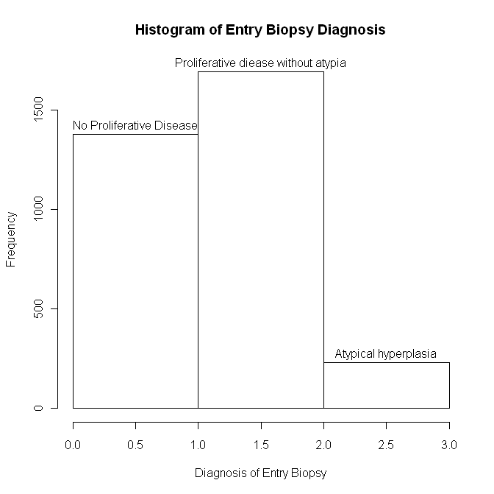

Below is a histogram of the study participants at their entry biopsy. As can be seen, the study follows people of many different age groups with the most populous age group being the 40s.
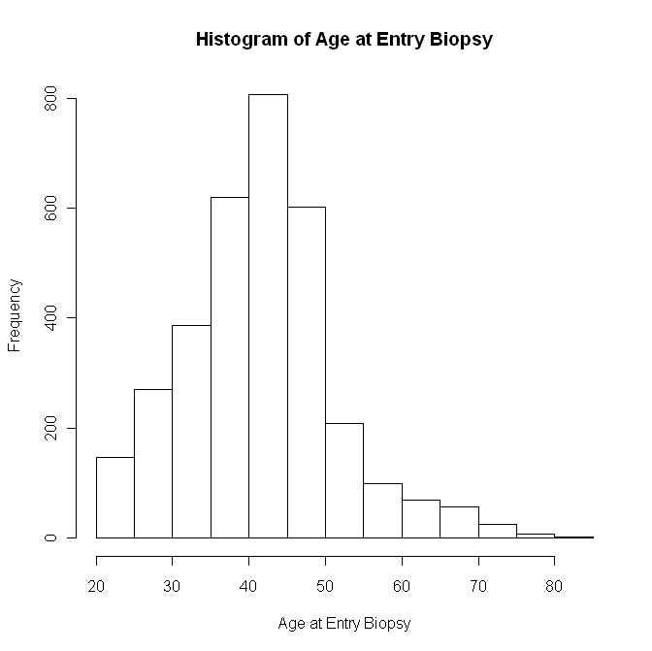
Below is a plot of the fate of the individual against the sum of the entry age and years of follow up (age at the end of the study or age at second mastectomy, cancer found or death occurred). There does not appear to be a strong pattern for this information.
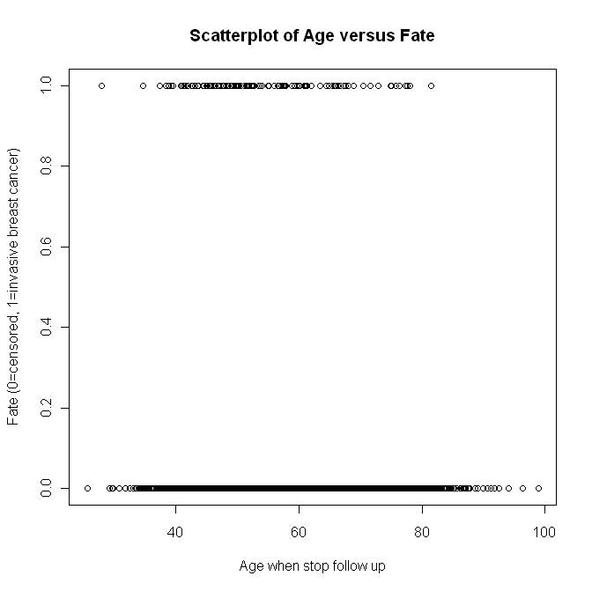

- Inference Data
In order to predict the fate of an individual, a multiple logistic regression can be used. We first created a model that utilizes entry age, family history, and diagnosis at the first biopsy. This model would be of the form
y = -4.404 + 0.0106 * entage + 0.576 * fh + 0.872 * pd
However, we noticed that the p-value of the Wald Test for the entry age was fairly high indicating that the entry age might not be an important variable in this logistic regression. We then created another, nested model (with a β value for entage = 0) with the form
y = -3.973 + .585 * fh + 0.901 * pd
To test which model is better using a likelihood ratio test, we took the differences of the deviances, which was equal to 1.4. This tests the null hypothesis H_{o} : β_{entage} = 0. Using a chi squared test with one degree of freedom gives a p-value of 0.763. The probability of our data given that our null hypothesis is true is 76.3%. This is not enough evidence to reject the null hypothesis. This p-value is also quite high so it is reasonable to believe that β_{entage} = 0, allowing the second model to be a better predictor of the fate of an individual.

Additionally, we constructed an odds ratio comparing the odds of invasive breast cancer for having a family history of breast cancer versus not having a family history of breast cancer (this odds ratio only compared fate and family history and did not adjust for other factors). We found the odds ratio to be 1.96. A 95% confidence interval of this odds ratio is (1.262, 3.057). Therefore, we are 95% confident that the true odds ratio of invasive breast cancer for having a family history of breast cancer versus not falls in the interval 1.262 to 3.057. As 1 is not included in this interval, we are 95% confident that there is a change in odds for a family history versus not.

