Math 151 – Probability
Fall 2020
Jo Hardin
iClicker Questions
to go with Probability and Statistics, DeGroot & Schervish
Section 1.4
- For “A union B”, the typical non-mathematical word to think of is:
- not
- and
- or
- sometimes

Section 1.4
- For “A intersect B”, the typical non-mathematical word to think of is:
- not
- and
- or
- sometimes

Section 1.4
- For “A complement”, the typical non-mathematical word to think of is:
- not
- and
- or
- sometimes

Section 1.5
- Let E and F be two events (subsets) in a sample space, S. ${(E∪F)}^{c}$ is the same as (this is the first of DeMorgan's Laws):

- $E^{c}∪ F^{c}$
- $E^{c}∩ F^{c}$
- ${(E∩F)}^{c}$

Section 1.5
- P(A $∪$ B) =

- P(A) + P(B)
- P(A) P(B)
- P(A) + P(B) - P(AB)
- P(A) - P(AB)
- P(AB) + P(AB^{c})

Section 1.5
- An Axiom is something that is provable.

  - TRUE
  - FALSE
  - I have no idea what an Axiom is

Section 1.6
- When playing poker, which hand wins: four of a kind, or a full house (three of a kind and a pair)?
[How would you decide?]
(a) four of a kind
(b) full house

Section 1.6
- Suppose we throw two fair, six-sided dice, and we add the numbers together. What is the probability of getting a 5?

D2\D1 | 1 | 2 | 3 | 4 | 5 | 6
1 | 2 | 3 | 4 | 5 | 6 | 7
2 | 3 | 4 | 5 | 6 | 7 | 8
3 | 4 | 5 | 6 | 7 | 8 | 9
4 | 5 | 6 | 7 | 8 | 9 | 10
5 | 6 | 7 | 8 | 9 | 10 | 11
6 | 7 | 8 | 9 | 10 | 11 | 12

- 1/6
- 1/9
- 4/6

Section 1.6
- Suppose two fair dice are rolled. What's the probability that the sum is even?

- 1/3
- 1/2
- 2/3

Section 1.6
- Suppose two fair dice are rolled. What is the probability that the sum is odd?
- 1/3
- 1/2
- 2/3

Section 1.6
11. Suppose two fair dice are rolled. What's the probability that the absolute difference between the two numbers is less than 3?

- 1/3
- 1/2
- 2/3

Section 1.7
- What is the probability that a randomly chosen license plate with five letters says "CHIRP"?

(a)$1/{{26}^{5}}$
(b) $\left({26 \atop 5}\right)$
(c) $1/{{52}^{5}}$
(d) $\left({26 \atop 10}\right)$
(e) $\left({52 \atop 5}\right)$

Section 1.7
12. How many ways are there to rearrange the letters in the word SECNARF?

(How many different words can you spell with those letters - they don't have to have known meanings?)

- 5!
- 26⁷
- 7⁷
- 7!

Section 1.7
11.The FAMOUS BIRTHDAY PROBLEM: What is the probability that two people in this room have the same birthday?
- 0 – 0.1
- 0.1 – 0.3
- 0.3 – 0.5
- 0.5 – 0.8
- 0.8 – 1

Section 1.7
12. What's the probability that at least two people in a group of k people share the same birthday? (i.e. their birthday is on the same day of the year).

- k/365
- ${\left(1/{365}\right)}^{k}$
- $\left({365 \atop k}\right)$ (“365 choose k”)
- None of the above.

Section 1.8

- P(A ∪ B) =

- P(A) + P(B)
- P(A) – P(B)
- P(A) + P(B) – P(AB)
- P(A) – P(AB)
- P(AB) + P(AB^{c})

Section 1.8

- 120 people are invited to a banquet. 12 people at each of 10 tables, seated randomly. What is the probability that person X and person Y (who can’t stand each other) are seated at the same table?

- less than 1/10
- 1/6
- between 1/6 and 1/2

Section 1.8
14. How do you prove that:
$$\sum_{k=0}^{n}{\left({n \atop k}\right)= 2^{n}}$$
- By induction
- By contradiction
- Using the Binomial Theorem
- By counting the same thing two ways

Section 1.8
15.Suppose 4 men and 4 women are randomly seated in a row. What's the probability that no 2 men or no 2 women sit next to each other?

- 1/8
- 1/16
- 1/32
- 1/35
- 1/47

Section 1.10
16. Suppose you are randomly choosing an integer between 1-10. Using unions what is the probability that the number is neither odd, nor prime, nor a multiple of 5.
- (5/10) + (4/10) + (2/10) – (3/10) – (1/10) – (1/10) + (1/10)
- 1 - (5/10) - (4/10) - (2/10) + (3/10) +(1/10) + (1/10) - (1/10)
- 1 - (5/10) - (4/10) - (2/10) + (3/10) - (1/10)
- 1 - (5/10) - (4/10) - (2/10) + (3/10)
- (5/10) + (4/10) + (2/10) - (3/10)

17.Baumgartner, Prosser, and Crowell are grading a calculus exam. There is a true-false question with ten parts. Baumgartner notices that one student has only two out of the ten correct and remarks, “The student was not even bright enough to have flipped a coin to determine his answers.” “Not so clear,” says Prosser. “With 340 students I bet that if they all flipped coins to determine their answers there would be at least one exam with two or fewer answers correct.” Crowell says, “I’m with Prosser. In fact, I bet that we should expect at least one exam in which no answer is correct if everyone is just guessing.”
Who is right in all of this?

- Baumgartner (expect only 2 right)
- Crowell (expect NONE right)
- Prosser (expect more right)

Section 2.1
18. Three cards are in a box:
  - Card 1: black on one side, red on the other
  - Card 2: black on both sides
  - Card 3: red on both sides.
You pull a card and only see one side. You note that it is red. What is the probability that you pulled Card 3?
- 0
- 1/3
- 1/2
- 2/3
- 1

Section 2.1
19. If two events A & B are disjoint:
(a) P(A|B) = P(A)
(b) P(A|B) = P(B)
(c) P(A|B) = P(AB)
(d) P(A|B) = 0

20. For the cab example, what is the probability that it is blue given that she said it was blue?
- 0-.2
- .2-.5
- .5-.7
- .7-.9
- .9-1
Section 2.2
21. Are the events independent?
E = event a businesswoman has blue eyes,
F = event her secretary has blue eyes.
- Independent events
- Not independent events

22. Are the events independent?

E = event a man is at least 6 ft. tall,
F = event he weighs over 200 pounds

- Independent events
- Not independent events

23. Are the events independent?
E = event a dog lives in the United States
F = the event that the dog lives in the western hemisphere.

- Independent events
- Not independent events

24. Are the events independent?

E = event it will rain tomorrow,
F = event it will rain the day after tomorrow

- Independent events
- Not independent events

25. Consider the relationship between disjoint and independent. Which of the following are true?
P(B) > 0, P(A) > 0:

- If A & B are disjoint → A&B are independent
- If A & B are indep → A&B are disjoint
- If A & B are disjoint → A&B are not independent
- If A & B are indep → A&B are not disjoint
- disjoint events and indep events are unrelated
- I don’t like any of these answers

26. See the clinical trial example in the notes. If we have no information about p, then all Bi are equally likely. Find P(E1).
(a) 1/11
(b) 5/11
(c) 1/2
(d) 6/11
(e) 10/11

27. What is the notation for the posterior (given the first person did not relapse) probability of the i^{th} value for the probability of relapse?
(a) P(B_i)
(b) P(E_1 | B_i)
(c) P(E_1)
(d) P(E_1 ∩ B_i)
(e) P(B_i | E_1)

28. What is the probability of the data (22 successes, 18 failures) given a particular B_j?
(a) $\frac{j-1}{10}$
(b) ${\left(p\right)}^{22}{\left(1-p\right)}^{18}$
(c) $\left({40 \atop 22}\right){\left(p\right)}^{22}{\left(1-p\right)}^{18}$
(d) ${\left(\frac{j-1}{10}\right)}^{22}{\left(\frac{11-j}{10}\right)}^{18}$
(e) $\left({40 \atop 22}\right){\left(\frac{j-1}{10}\right)}^{22}{\left(\frac{11-j}{10}\right)}^{18}$

29. Which sets of events are disjoint?

Yi = i^{th} year student (assume Yi, I =1,2,3,4 partition)
M = math major

- (M ∪ Y1) & (M ∪ Y2) & (M ∪ Y3) & (M ∪ Y4)
- (M ∩ Y1) & (M ∩ Y2) & (M ∩ Y3) & (M ∩ Y4)
- neither set of events is necessarily disjoint

30. Consider the math major setting. What is a way to consider the probability of being a math major?

Yi = i^{th} year student (assume Yi, I =1,2,3,4 partition)
M = math major

P(M) =
- P(M ∪ Y1) + P(M ∪ Y2) + P(M ∪ Y3) + P(M ∪ Y4)
- P(M ∩ Y1) + P(M ∩ Y2) + P(M ∩ Y3) + P(M ∩ Y4)
- P(M | Y1) + P(M | Y2) + P(M | Y3) + P(M | Y4)

31. Which sets of events are disjoint?

(a) (M ∪ Y1) and (M ∪ Y2) and (M ∪ Y3) and (M ∪ Y4)
(b) (M ∩ Y1) and (M ∩ Y2) and (M ∩ Y3) and (M ∩ Y4)
(c) neither

32. P(X = 3) = P( s ϵ S: s contains 3 heads and 7 tails)
(a) 3/10
(b) (1/2)^3
(c) (1/2) ^10
(d) $\left({10 \atop 3}\right){\left(\frac{1}{2}\right)}^{10}$

33. Suppose that two balanced dice are rolled, and let X denote the absolute value of the difference between the two numbers that appear. Which is the p.f. of X?
(a) 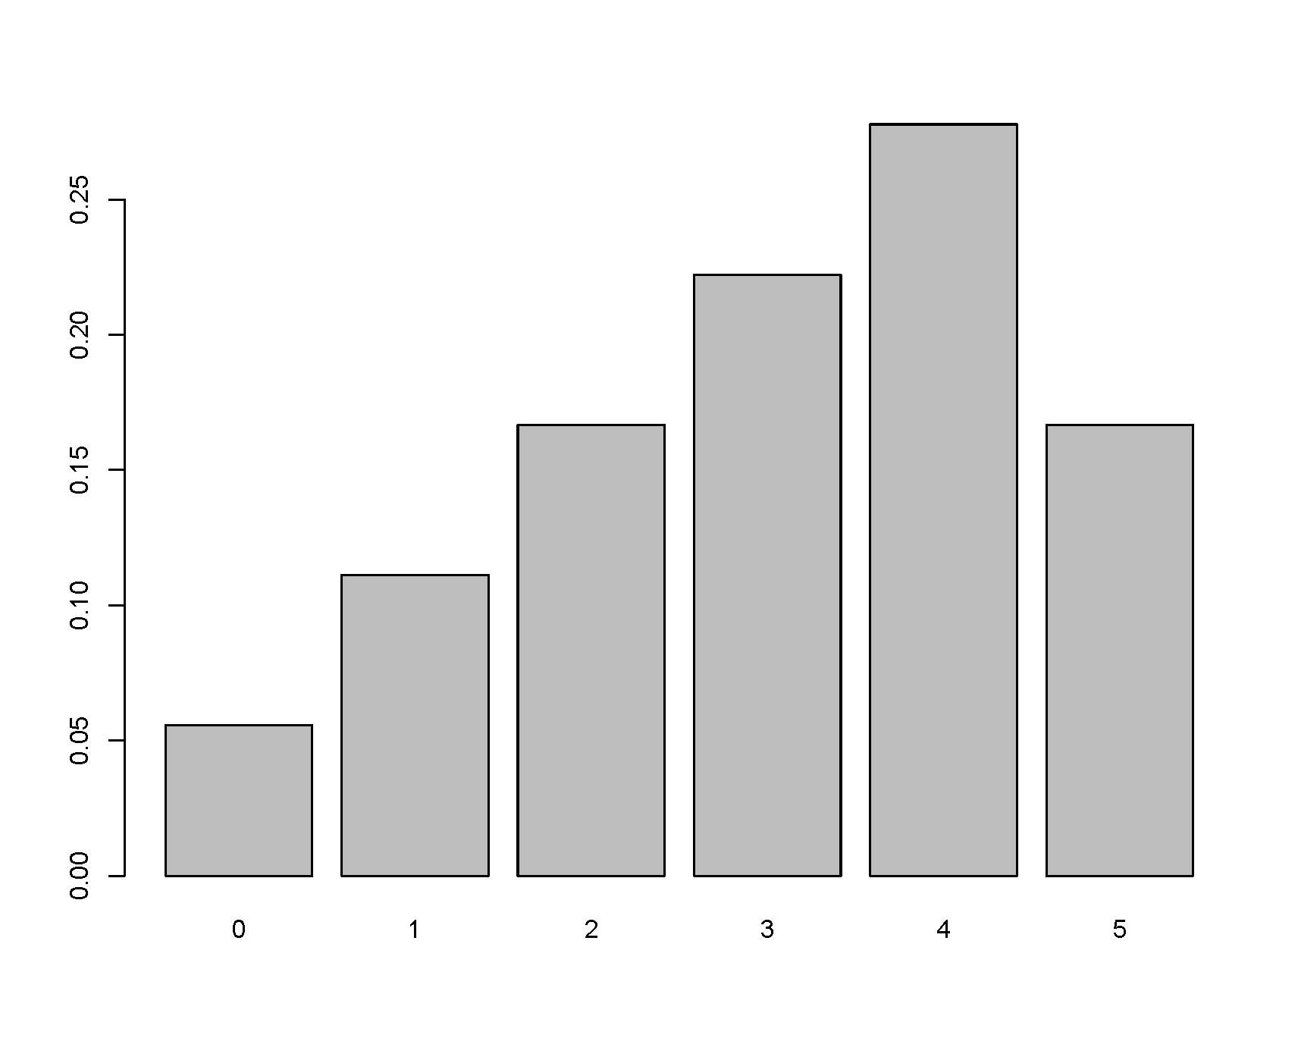 (c) 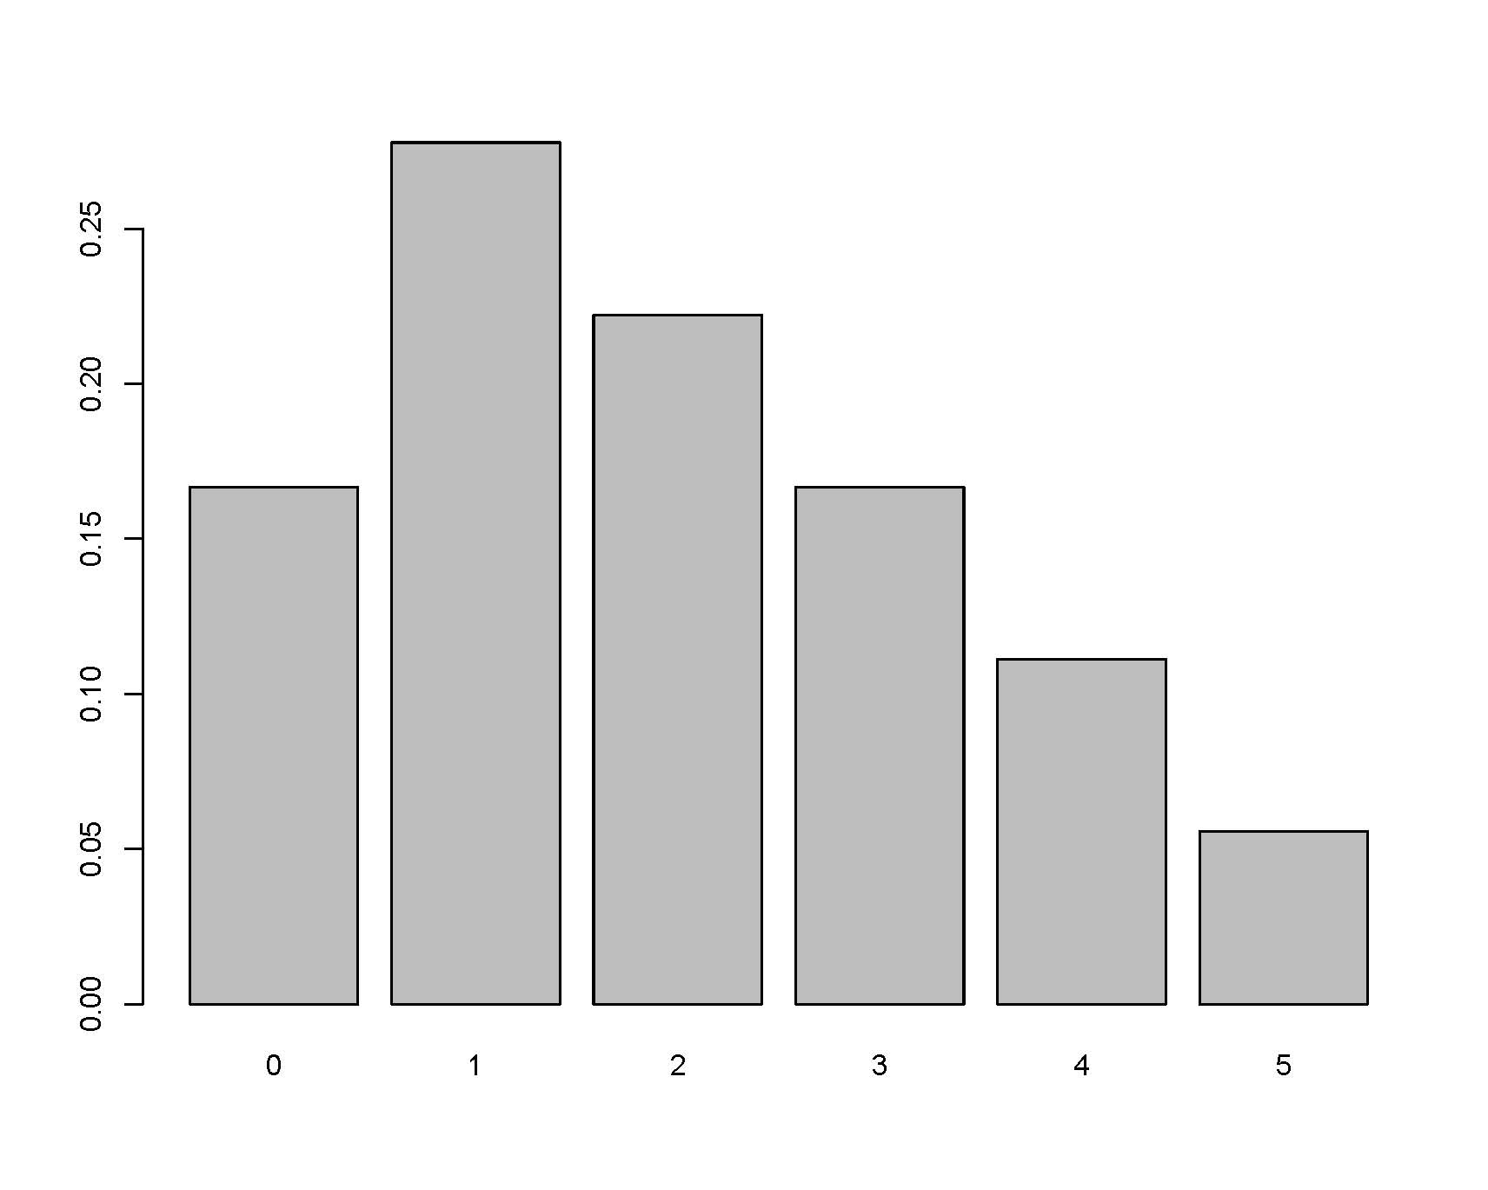

(b) 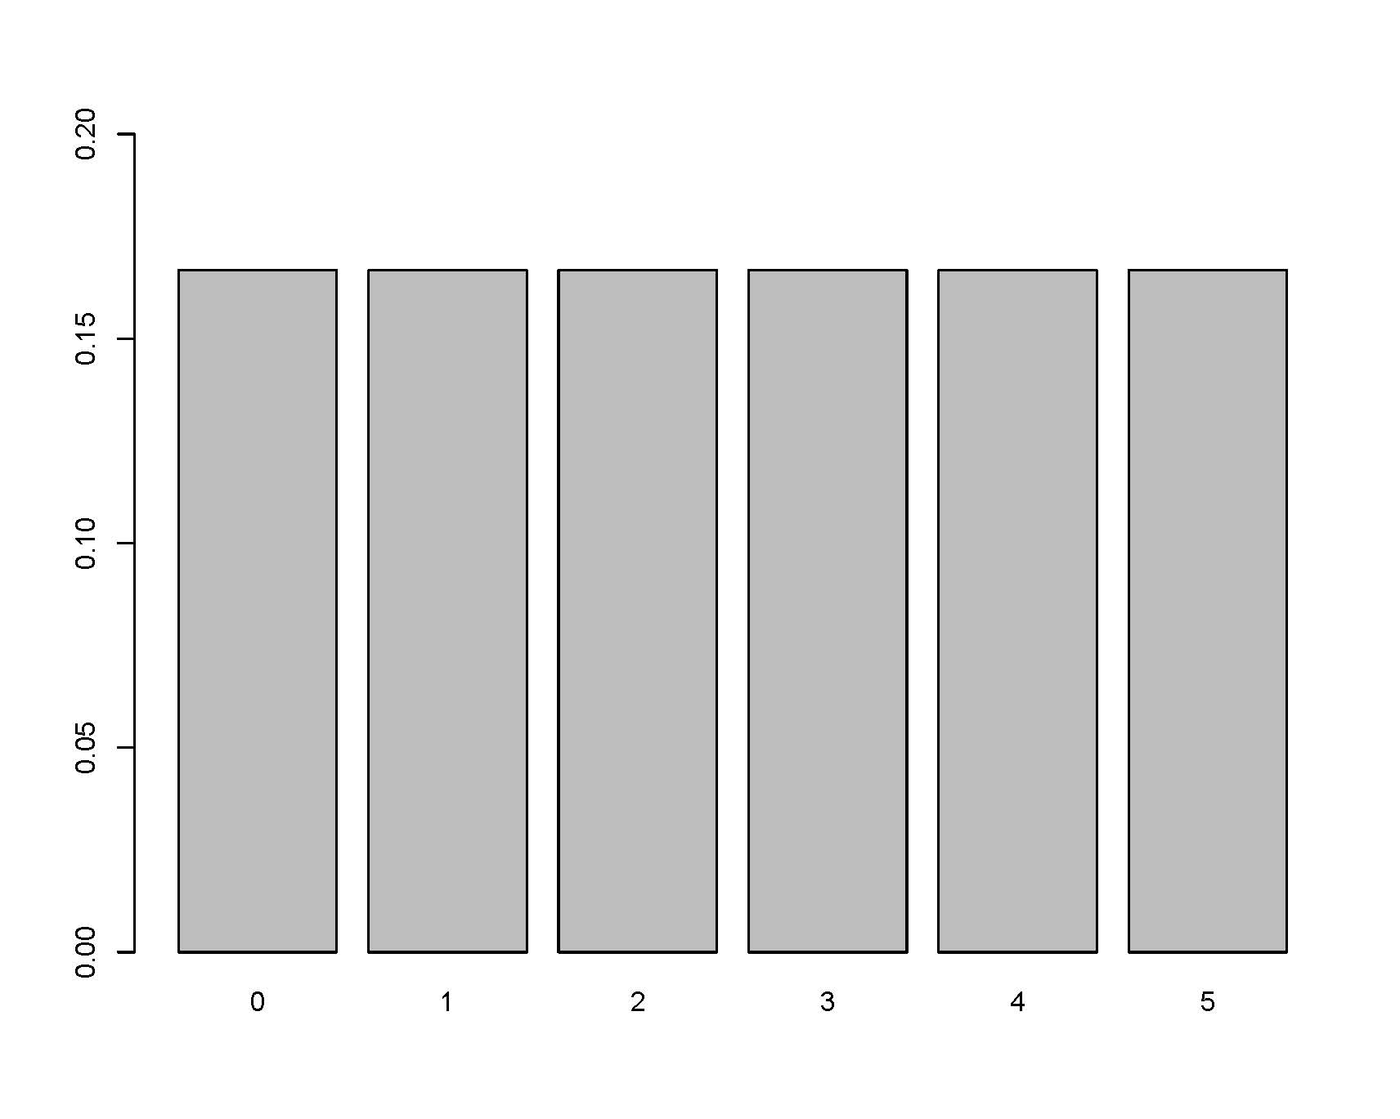

34. Suppose that two balanced dice are rolled, and let X denote the absolute value of the difference between the two numbers that appear. Find the value of c:
X | 0 | 1 | 2 | 3 | 4 | 5
f(x) | c*3 | c*5 | c*4 | c*3 | c*2 | c*1

(a) 1/2
(b) 1/6
(c) 1/9
(d) 1/18
(e) 1/36

35. Suppose that X is distributed according to the pdf f(x) such that:
$f(x) = ce^{-2x} x>0.$
Find the value of c.
a. -2
b. -1/2
c. 1/2
d. 1
e. 2

36. Suppose that X is distributed according to the pdf f(x) such that:
$f(x) = 2e^{-2x} x>0.$
Find P(X >2).
a. $1-{2e}^{-4}$
b. ${2e}^{-4}$
c. $1-e^{-4}$
d. $e^{-4}$
e. 0

37. Suppose that X is distributed according to the pdf f(x) such that:
$f(x) = 2e^{-2x} x>0.$
Find P(X = 2).
a. $1-{2e}^{-4}$
b. ${2e}^{-4}$
c. $1-e^{-4}$
d. $e^{-4}$
e. 0

38. If X is modeled according to a discrete distribution:
P(X = x) = f(x)
    - TRUE
    - FALSE
    - I don’t know what discrete means
    - it depends on what f is

39. If X is modeled according to a continuous distribution:
P(X = x) = f(x)
- TRUE
- FALSE
- I don’t know what continuous means
- it depends on what f is

40. The CDF of a binomial random variable
(e.g., X ~ Bin(47, 0.47) ) is continuous.

(a) TRUE
(b) FALSE

41. For X, a continuous random variable, the pdf, f(x), is defined to be:
(a) The function which gives the probability of X
(b) The function which gives the cumulative probability of X
(c) The function such that when integrated over some interval gives the probability of X in that interval.
(d) The function such that when differentiated gives the probability of X.

42. Suppose that the cdf of a random variable X is as follows:
$$F\left(x\right)= \left\{\begin{aligned}0 x ≤0 \\ \left(\frac{1}{9}\right)x^{2} 0<x ≤3 \\ 1 x>3\end{aligned}\right.$$

What is the pdf of X? (Sketch the pdf.)
What is P(1 < X < 2)?
(a) 1/2
(b) 1/3
(c) 1/4
(d) 2/3

43. The HW so far is:

- Just right
- Way too hard
- Book problems okay, but no idea what is going on with R
- R problem okay, but book problems way too hard
- Right level but too long

44. Suppose the joint density of X and Y is
$$f_{XY}\left(x,y\right)=cx^{2}y x^{2} ≤y ≤1$$
What is c?
(a) 1
(b) 1/2
(c) 21/4
(d) no clue how to start this problem.
(e) I know how to start the problem, but I get stuck

45. Suppose the joint density of X and Y is
$$f_{XY}\left(x,y\right)=(\frac{21}{4})x^{2}y x^{2} ≤y ≤1$$

What is P(X ≥ Y) ?

(a) 3/20
(b) 1/2
(c) 1/4
(d) No clue how to start this problem
(e) I know how to start the problem, but I get stuck

46. Suppose the joint density of X and Y is
$$f_{XY}\left(x,y\right)=(\frac{21}{4})x^{2}y x^{2} ≤y ≤1$$

What is P(X ≤ 0) ?

(a) 1
(b) 0
(c) 1/2
(d) 21/24 + 1/14
(e) none of these

47. Suppose X and Y have joint cdf:
$$F_{XY}\left(x,y\right)=\left(\frac{1}{16}\right)xy(x+y)$$
To find the joint pdf of X and Y, $f_{XY} (x,y)$, we should:
(a) take the derivative (wrt to what?)
(b) integrate (wrt to what?)
(c) plug in values for x and/or y (what values?)
(d) I don’t know how to do this problem

48. Suppose X and Y have joint cdf:
$$F_{XY}\left(x,y\right)=\left(\frac{1}{16}\right)xy(x+y)$$
To find the marginal cdf of X, $F_{X} (x)$, we should:
(a) take the derivative (wrt to what?)
(b) integrate (wrt to what?)
(c) plug in values for x and/or y (what values?)
(d) I don’t know how to do this problem

49. Suppose X and Y have joint cdf:
$$F_{XY}\left(x,y\right)=\left(\frac{1}{16}\right)xy(x+y)$$
To find the marginal pdf of X, $f_{X} (x)$, we should:
(a) take the derivative (wrt to what?)
(b) integrate (wrt to what?)
(c) plug in values for x and/or y (what values?)
(d) I don’t know how to do this problem

50. Let f_{XY}(x,y), f_{X}(x) and f_{Y}(y) be joint and marginal pdf functions. The conditional pdf of X given Y=y is:

(a) f_{X}(x)* f_{Y}(y)
(b) f_{X}(x)/ f_{Y}(y)
(c) f_{XY}(x,y)/ f_{X}(x)
(d) f_{XY}(x,y)/f_{Y}(y)

51. Let f_{X|y}(x|y), f_{X}(x) and f_{Y}(y) be conditional and marginal pdf functions. The joint pdf of X and Y is:

(a) f_{X}(x)* f_{Y}(y)
(b) f_{X}(x)/ f_{Y}(y)
(c) f_{X|y}(x|y) * f_{X}(x)
(d) f_{X|y}(x|y) * f_{Y}(y)
(e) f_{X|y}(x|y) / f_{Y}(y)

52. Suppose either of two instruments could be used for making a measurement (X). Instrument 1 has pdf:
f_{X1}(x) = 2x 0 < x < 1
and Instrument 2 has pdf:
f_{X2}(x) = 3x² 0 < x < 1
One instrument is chosen randomly. What is the joint pdf of measurement & choice (Y=1 if first, Y=0 if second):
(a) f_{XY} (x,y) = y (1/2)2x + (1-y) (1/2) 3x²
(a) f_{XY} (x,y) = y 2x + (1-y) 3x²
(c) f_{XY} (x,y) = (1/2) 2x + (1/2) 3x²
(d) f_{XY} (x,y) = y 2x * (1-y) 3x²
(e) f_{XY} (x,y) = y2x + (1-y) 3x²

53. Given 3 RVs: X, Y, Z, you know
$$f_{X|z}(x|z)=f_{X}(x)$$
$$f_{Y|z }\left(y | z\right)=f_{Y}(y)$$
(a) X & Y & Z are definitely independent
(b) X & Y & Z are definitely not independent
(c) we don’t have enough information to determine the independence of X & Y & Z.

54. Find $P\left(X ≤2 \right| Y≤4, Z ≤5)$

(a) $F_{XYZ}(2,4,5)$
(b) $\int_{-∞}^{2}{f_{X|y,z} \left(x\right|4,5)} dx$
(c) $\int_{-∞}^{2}{\frac{f_{X|y,z} \left(x\right|4,5)}{F_{YZ} (4,5)}} dx$
(d) $\frac{F_{XYZ} (2,4,5)}{F_{YZ} (4,5)}$

56. Given the waiting times example (5 people Xi represents the time to serve customer i), what is the conditional density of X1 given the other 4 waiting times?

(a) $\frac{f_{X1}(x1)}{f_{X1, X2,X3, X4, X5} (x1, x2, x3, x4, x5)}$
(b) $\frac{f_{X1}(x1)}{f_{X2,X3, X4, X5} (x2, x3, x4, x5)}$
(c) $\frac{ f_{X2,X3, X4, X5} (x2, x3, x4, x5)}{f_{X1}\left(x1\right)}$
(d) $\frac{ f_{X1, X2,X3, X4, X5} (x1,x2, x3, x4, x5)}{f_{X1}\left(x1\right)}$
(e) $\frac{ f_{X1, X2,X3, X4, X5} (x1,x2, x3, x4, x5)}{f_{X2,X3, X4, X5} (x2, x3, x4, x5)}$

57. Given the waiting times example, what is the marginal density of X1?
(a) $\iiint_{-∞}^{∞}{f_{X1, X2,X3, X4, X5} \left(x1,x2, x3, x4, x5\right) dx1 dx2 dx3 dx4 dx5}$

(b) $\iiint_{-∞}^{∞}{f_{X1, X2,X3, X4, X5} \left(x1,x2, x3, x4, x5\right) dx2 dx3 dx4 dx5}$

(c) $\iiint_{-∞}^{∞}{f_{ X2,X3, X4, X5} \left(x2, x3, x4, x5\right) dx1 dx2 dx3 dx4 dx5}$

(d) $\iiint_{-∞}^{∞}{f_{ X2,X3, X4, X5} \left(x2, x3, x4, x5\right) dx2 dx3 dx4 dx5}$

58. X ~ U[0,1], gives Y = X², $f_{Y}\left(y\right)= \frac{1}{2\sqrt{y}} 0 ≤y≤1$

What if X ~ U[-1,1], what is the pdf of Y = X² ?

(a) $f_{Y}\left(y\right)= \frac{1}{2\sqrt{y}} 0 ≤y≤1$
(b) $f_{Y}\left(y\right)= \frac{1}{2\sqrt{|y|}} -1 ≤y≤1$
(c) $f_{Y}\left(y\right)= \frac{1}{\sqrt{y}} 0 ≤y≤1$
(d) $f_{Y}\left(y\right)= \frac{1}{2y^{2}} -1 ≤y≤1$

59. Let X = number of buses that arrive in a given hour.
I’m more interested in Y = 47*X, the number of seats available for passengers in a given hour.

Can I use the formula (change of variable theorem) for finding the pdf of Y?

(a) Yes, because X is continuous
(b) No, because X is not continuous
(c) Yes, because “h” is strictly increasing
(d) No, because “h” is not strictly increasing

60. At time=0, v₀ organisms are put in a large tank of water, where X is the (unknown) rate of growth:
v₀(t) = Xv(t) → v(t) = v₀e^{Xt}
Suppose X has a pdf:
f_{X}(x) = 3(1 - x)² 0 < x < 1
What is the density of Y = v₀e^{Xt}? To be specific, if v₀ = 10, what is the distribution of the organisms at t = 5?
A. f_{Y} (y) = e^{15(1-y)^2} 10 < y < 10e⁵.
B. f_{Y} (y) = 3(1 - ln(y/10) / 5)² / (5y) 0 < y < 1.
C. f_{Y} (y) = 3(1 - ln(y/10) / 5)² / (5y) 10 < y < 10e⁵

61. If $F_{X1, X2, X3, X4} (x1, x2, x3, x4)$ is the joint CDF, we know:
(a) $0 ≤F_{X1, X2, X3, X4} \left(x1, x2, x3, x4\right)≤∞$
(b) $0 ≤F_{X1, X2, X3, X4} \left(x1, x2, x3, x4\right)≤1$
(c) $-∞ ≤F_{X1, X2, X3, X4} \left(x1, x2, x3, x4\right)≤∞$

62. If $f_{X1, X2, X3, X4} (x1, x2, x3, x4)$ is the joint PDF, we know:
(a) $0 ≤f_{X1, X2, X3, X4} \left(x1, x2, x3, x4\right)≤∞$
(b) $0 ≤f_{X1, X2, X3, X4} \left(x1, x2, x3, x4\right)≤1$
(c) $-∞ ≤f_{X1, X2, X3, X4} \left(x1, x2, x3, x4\right)≤∞$

63. If (X,Y) is a bivariate discrete random variable on the natural numbers ( $\left(X,Y\right)∈N^{2}$), the number of values which Z = X-Y can take on is:
(a) infinite & non-negative
(b) infinite & positive or negative
(c) finite & positive
(d) finite & positive or negative
(e) none of the above

64. Consider a random sample of n continuous observations (from the same distribution, F_{X}).
Find: P(smallest observation ≤ y)

(a) (F_{X}(y) )^{n}
(b) (1 - F_{X}(y) )^{n}
(c) n*(F_{X}(y) )
(d) 1 - (1 - F_{X}(y) )^{n}
(e) (1 - F_{X}(x) )^{n}

65. Consider a random sample of n continuous observations (from the same distribution, F_{X}).

Find: P(largest observation ≤ y)

(a) (F_{X}(y) )^{n}
(b) (1 - F_{X}(y) )^{n}
(c) n*(F_{X}(y) )
(d) 1 - (1 - F_{X}(y) )^{n}
(e) (F_{X}(x) )^{n}

59. Suppose a die has four faces with a 6 on them, and two faces with a 2 on them. The die is thrown many times. What is the average of the numbers that you see?
a. 3
b. 3.5
c. 4
d. > 4

60. Suppose the amount of time, in weeks, you remember what you learned in this class is a random variable with density function:

$$f\left(x\right)= .01 e^{-x/100} x>0$$
What is the expected amount of time you'll remember the material in this class?
a. 50 weeks
b. 100 weeks
c. 150 weeks

61. A random variable X has a Bernoulli Distribution with parameter p if X can be either 0 or 1, and P(X = 1) = p.

What is E[X]?

a. p
b. (1-p)
c. p(1-p)
d. not enough information

62. The Cauchy density is:
$$f\left(x\right)=\frac{1}{π\left(1+ x^{2}\right)} -∞<x< ∞$$

What is E[X]?

a. 0
b. 0.3
c. infinity
d. none of these

63. X ~ U[0,1] , let Y = e^{X}. Find: E[e^{X}]

(a) e^{0.5}
(b) e¹
(c) e – 1
(d) 1

64. Suppose a point is chosen at random in the unit square. Find its expected squared distance from the origin.

(a) 0.5
(b) π/4
(c) 2/3

65. The expected value of X:
(a) is always positive
(b) is always a possible value for X (i.e., is one of the values within the support of X)
(c) is a parameter
(d) some of the above
(e) all of the above

66. Let X be distributed continuous uniform on the interval [0,10], find the expected value and variance of X.
(a) E[X] = 5, Var(X) = 5
(b) E[X] = 5, Var(X) = 2.897
(c) E[X] = 5, Var(X) = 8$\frac{1}{3}$

67. Y ~ Bin(47,.9) E(Y) = ?

(a) np (= 47*0.9)
(b) n(1-p) (=47*0.1)
(c) p (=0.1)
(d) np(1-p) (=47*0.9*0.1)

68. Y ~ Bin(47,.9) Var(Y) = ?
(a) np² ( = 47 * 0.9²)
(b) np² - n²p² ( = 47 * 0.9²- 47² * 0.9²)
(c) np(1-p) ( = 47*0.9 * 0.1)

69. X ~ Bin(47,.9) Skew(X) = ?

(a) 0.3890
(b) - 0.3890

70. ψ(t) = E[ e^{tX}], ψ(0) = ?

(a) 1
(b) 0
(c) depends on the distribution of X

71. f(x) = e^{-x} x ≥ 0, ψ(t) = E[ e^{tX}] = ?

(a) 1/t
(b) 1/(1-t)
(c) t
(d) (1-t)
(e) -1/(1-t)

72. f(x) = e^{-x} x ≥ 0, ψ(t) = E[ e^{tX}] = ?

(a) exists for all t > 0
(b) exists for all t < 0
(c) exists for all t > 1
(d) exists for all t < 1

73. f(x) = e^{-x} x ≥ 0, ψ(t) = E[ e^{tX}] = 1/(1-t), Var(X) = ?

(a) 0
(b) 1
(c) 2

74. Consider a random sample, X1, X2, … Xn. What is E[$\prod_{i=1}^{n}{X_{i}^{2}}$] ?

(a) E[$\prod_{i=1}^{n}{X_{i}}$]²
(b) [$\prod_{i=1}^{n}{E\left[X_{i}^{2}\right] }$]
(c) [$\prod_{i=1}^{n}{{{E[X}_{i}]}^{2}}]$
(d) (E[$\prod_{i=1}^{n}{X_{i}}$] )²

75. Suppose the pdf of X is:

f(x) = 4x³ 0 ≤ x ≤ 1

The median of X is
- 4(1/2)³
- (1/2)⁴
- (1/2)^{1/4}
- (4/5)(1/2)⁵
- None of these

76. Suppose the pdf of X is:
$$f\left(x\right)= \left\{\begin{aligned}\frac{1}{2} 0 ≤x ≤1 \\ 1 2.5 ≤x ≤3 \\ 0 else\end{aligned}\right.$$

The median of X is
- 1
- 1.75
- 2.5
- X has infinitely many medians

77. If X and Y are independent, then Cov(X,Y) =

(a) 1
(b) 0
(c) varies

78. Suppose X = -1, 0, 1 with equal probability. Y = X²

Find Cov(X,Y).

(a) 1
(b) 0
(c) -1
(d) none of these

that is: the covariance between X and Y is zero, but we also know that X and Y are definitely not independent.
That is, independence leads to zero covariance, but the reverse is not true.

79. Let X and Y have the joint distribution:

f(x,y) = x + y 0 ≤ x ≤ 1, 0 ≤ y ≤ 1

Are X and Y independent?

(a) Yes
(b) No

79. True or False: ρ(X,Y) ≤ 1
(a) True
(b) False

80. If ρ(X,Y) = -1, then

(a) $Y = a - \frac{σ_{x}}{σ_{y}} X$
(b) Y = -X
(c) $Y = -a - \frac{σ_{x}}{σ_{y}} X$

81. Consider the following dice game: players 1 and 2 roll in turn a pair of dice (they each roll a pair). Then the bank rolls a pair of dice. If a player's roll is strictly higher than the bank's roll, the player wins.

Are the two player's winnings correlated?

(a) Yes, they are negatively correlated.
(b) Yes, they are positively correlated.
(c) No, they are not correlated.

82. Let X and Y denote the values of two stocks at the end of a five-year period. X is uniformly distributed on the interval (0, 12) . Given X = x, Y is uniformly distributed on the interval (0, x).
Are the two stock values correlated?

(a) Yes, they are negatively correlated.
(b) Yes, they are positively correlated.
(c) No, they are not correlated.

83. Suppose that we record the midterm exam score and the final exam score for every student in a class. What would the value of the correlation coefficient be if every student in the class scored ten points higher on the final than on the midterm:
(a) ρ = -1
(b) -1 < ρ < 0
(c) ρ = 0
(d) 0 < ρ < 1
(e) ρ = 1

84. Suppose that we record the midterm exam score and the final exam score for every student in a class. What would the value of the correlation coefficient be if every student in the class scored five points lower on the final than on the midterm:
(a) ρ = -1
(b) -1 < ρ < 0
(c) ρ = 0
(d) 0 < ρ < 1
(e) ρ = 1

85. To calculate probabilities of a RV, we need to know:
(a) the pdf
(b) the cdf
(c) the mgf
(d) the first few moments
(e) the above are all equivalent

86. To bound probabilities of a RV, we need to know:
(a) the pdf
(b) the cdf
(c) the mgf
(d) the first few moments
(e) the above are all equivalent

87. Let X and Y be independent N(5, σ² = 4) random variables. Using Markov’s Inequality, what can we say about
P(X+Y ≥ 12) ?
(a) ≤ 1
(b) ≤ 0.5
(c) ≥ 1
(d) ≥ 0.5
(e) nothing

88. Let X and Y be independent N(5, σ² = 4) random variables. Using Chebyshev’s Inequality, what can we say about
P(|X+Y – 10 | ≥ 2) ?
(a) ≤ 1
(b) ≤ 0.5
(c) ≥ 1
(d) ≥ 0.5
(e) nothing

89. Let X and Y be independent N(5, σ² = 4) random variables. Using Chebyshev’s Inequality, what can we say about
P(|X+Y – 10 | ≥ 3) ?
(a) ≤ 1
(b) ≤ 8/9
(c) ≥ 1
(d) ≥ 8/9
(e) nothing

90. If we repeatedly flip a coin 16 times, what percent of the time will the simulation flip exactly 8 heads?
- 0-15%
- 16-30%
- 31-49%
- 50%
- 51-100%

91. What if we flipped a coin 160 times? What percent of the time will the simulation flip exactly 80 heads?
- 0-15%
- 16-30%
- 31-49%
- 50%
- 51-100%

92. X ~ Bin(n,p). $E\left[e^{tX}\right]=$

(a) $\sum_{k=1}^{n}{ \left({n \atop k}\right) (e^{t}{p)}^{k}{(1-p)}^{n-k}}$
(b) $\sum_{k=1}^{n}{ \left({n \atop k}\right) e^{tk}({p)}^{k}{(1-p)}^{n-k}}$
(c) $\sum_{k=0}^{n}{ \left({n \atop k}\right) ({p)}^{k}{(e^{t}(1-p))}^{n-k}}$
(d) $\sum_{k=0}^{n}{ \left({n \atop k}\right) (e^{t}{p)}^{k}{(1-p)}^{n-k}}$
(e) $\sum_{k=0}^{n}{ \left({n \atop k}\right) e^{tX}({p)}^{k}{(1-p)}^{n-k}}$

93. $X_{i}$ ~ Bernoulli (p) Find MGF of $\sum_{i=1}^{n}{X_{i}}$

- $p e^{t}+\left(1-p\right)$
- $(1-p) e^{t}+p$
- ${(p e^{t}+\left(1-p\right))}^{n}$
- ${(p e^{t}+\left(1-p\right))}^{t}$
- ${(p e^{t/n}+\left(1-p\right))}^{n}$

94. $X_{i}$ ~ Bernoulli (p) Find MGF of $\hat{p}= \sum{X_{i}/n}$

- $p e^{t}+\left(1-p\right)$
- $(1-p) e^{t}+p$
- ${(p e^{t}+\left(1-p\right))}^{n}$
- ${(p e^{t}+\left(1-p\right))}^{t}$
- ${(p e^{t/n}+\left(1-p\right))}^{n}$

95. Let X ~ Poisson such that P(X=1) = P(X=2). The rate (λ) of the Poisson distribution is:

(a) λ = 0.5
(b) λ = 1
(c) λ = 2
(d) λ = 5
(e) λ does not exist

96. The standard deviation of a Poisson distribution is 2. What is its mean?

(a) 1
(b) 2
(c) 4
(d) 8

97. The variance of a binomial distribution is _______ its mean.

(a) smaller than
(b) the same as
(c) bigger than

98. The variance of a Poisson distribution is _______ its mean.

(a) smaller than
(b) the same as
(c) bigger than

99. If X~Poisson (λ), an approximately equivalent distribution is:
(a) Bernoulli (λ/n)
(b) Bernoulli (λ*n)
(c) Binomial (n, λ/n)
(d) Binomial (n, λ*n)

p.s. What is n???

100. If X ~ N(8, 64 (var) ), then the standard normal deviate is:

(a) Z = (X-64)/8
(b) Z = (X-8)/64
(c) Z = (X-8)/8
(d) Z = (8-X)/8

101. Which of the transformations give normal random variables? If X ~ N(8, 64 (var) ):

() Z = (X-64)/8
(a) Z = (X-8)/64
(b) Z = (X-8)/8
(c) Z = (8-X)/8
(d) all
(e) some

102. The variance of the sample mean is:
(a) larger than the variance of the data
(b) the same as the variance of the data
(c) smaller than the variance of the data
(d) unrelated to the variance of the data

103. Suppose that the heights of men and women in a certain population are distributed as
N(68, 3^2 = 9) and N(65, 1), respectively.
If one man and one woman are randomly selected, what is the probability that the woman will be taller than the man?
(a) 0-0.1
(b) 0.1-0.4
(c) 0.4 – 0.6
(d) 0.6 – 0.9
(e) 0.9 – 1

