Math 151 – Probability
Spring 2019
Jo Hardin
iClicker Questions
to go with Probability and Statistics, DeGroot & Schervish

Section 1.6
- When playing poker, which hand wins: four of a kind, or a full house (three of a kind and a pair)?
[How would you decide?]
(a) four of a kind
(b) full house

Section 1.6
- Suppose we throw two fair, six-sided dice, and we add the numbers together. What is the probability of getting a 5?
D2\D1 | 1 | 2 | 3 | 4 | 5 | 6
1 | 2 | 3 | 4 | 5 | 6 | 7
2 | 3 | 4 | 5 | 6 | 7 | 8
3 | 4 | 5 | 6 | 7 | 8 | 9
4 | 5 | 6 | 7 | 8 | 9 | 10
5 | 6 | 7 | 8 | 9 | 10 | 11
6 | 7 | 8 | 9 | 10 | 11 | 12

- 1/6
- 1/9
- 4/6

Section 1.6
- Suppose two fair dice are rolled. What's the probability that the sum is even?

- 1/3
- 1/2
- 2/3

Section 1.6
- Suppose two fair dice are rolled. What's the probability that the sum is odd?

- 1/3
- 1/2
- 2/3

Section 1.6
- Suppose two fair dice are rolled. What's the probability that the difference between the two numbers is less than 3?

- 1/3
- 1/2
- 2/3

- The FAMOUS BIRTHDAY PROBLEM: What is the probability that two people in this room have the same birthday?
- 0 – 0.1
- 0.1 – 0.3
- 0.3 – 0.5
- 0.5 – 0.8
- 0.8 – 1

Section 1.7
- What's the probability that a randomly chosen license plate with five letters (upper and lower case) says “Chirp”?

(a)$1/{{26}^{5}}$
(b) $\left({26 \atop 5}\right)$
(c) $1/{{52}^{5}}$
(d) $\left({26 \atop 10}\right)$
(e) $\left({52 \atop 5}\right)$

Section 1.5
8. Let E and F be two events (subsets) in a sample space, S. ${(E∪F)}^{c}$ is the same as (this is the first of DeMorgan's Laws):

- $E^{c}∪ F^{c}$
- $E^{c}∩ F^{c}$
- ${(E∩F)}^{c}$

Section 1.5
9. P(A $∪$ B) =

- P(A) + P(B)
- P(A) P(B)
- P(A) + P(B) - P(AB)
- P(A) - P(AB)
- P(AB) + P(AB^{c})

Section 1.7
10. How many ways are there to rearrange the letters in the word POMONA? (How many different words can you spell with those letters - they don't have to have known meanings?)

- 3!
- 26^6
- 360
- 6!

Section 1.7
11.The FAMOUS BIRTHDAY PROBLEM: What is the probability that two people in this room have the same birthday?
- 0 – 0.1
- 0.1 – 0.3
- 0.3 – 0.5
- 0.5 – 0.8
- 0.8 – 1

Section 1.7
12. What's the probability that at least two people in a group of k people share the same birthday? (i.e. their birthday is on the same day of the year).

- k/365
- ${\left(1/{365}\right)}^{k}$
- $\left({365 \atop k}\right)$ (“365 choose k”)
- None of the above.

Section 10.5

13. 120 people are invited to a banquet. 12 people at each of 10 tables, seated randomly. What is the probability that person X and person Y (who can’t stand each other) are seated at the same table?

- less than 1/10
- 1/6
- between 1/6 and 1/2

Section 1.8
14. How do you prove that:
$$\sum_{k=0}^{n}{\left({n \atop k}\right)= 2^{n}}$$
- By induction
- By contradiction
- Using the Binomial Theorem
- By counting the same thing two ways

Section 1.8
15.Suppose 4 men and 4 women are randomly seated in a row. What's the probability that no 2 men or no 2 women sit next to each other?

- 1/8
- 1/16
- 1/32
- 1/35
- 1/47

Section 1.10
16. Suppose you are randomly choosing an integer between 1-10. Using unions what is the probability that the number is neither odd, nor prime, nor a multiple of 5.
- (5/10) + (4/10) + (2/10) – (3/10) – (1/10) – (1/10) + (1/10)
- 1 - (5/10) - (4/10) - (2/10) + (3/10) +(1/10) + (1/10) - (1/10)
- 1 - (5/10) - (4/10) - (2/10) + (3/10) - (1/10)
- 1 - (5/10) - (4/10) - (2/10) + (3/10)
- (5/10) + (4/10) + (2/10) - (3/10)

17.Baumgartner, Prosser, and Crowell are grading a calculus exam. There is a true-false question with ten parts. Baumgartner notices that one student has only two out of the ten correct and remarks, “The student was not even bright enough to have flipped a coin to determine his answers.” “Not so clear,” says Prosser. “With 340 students I bet that if they all flipped coins to determine their answers there would be at least one exam with two or fewer answers correct.” Crowell says, “I’m with Prosser. In fact, I bet that we should expect at least one exam in which no answer is correct if everyone is just guessing.”
Who is right in all of this?

- Baumgartner (expect only 2 right)
- Crowell (expect NONE right)
- Prosser (expect more right)

Section 2.1
18. If two events A & B are disjoint:
(a) P(A|B) = P(A)
(b) P(A|B) = P(B)
(c) P(A|B) = P(AB)
(d) P(A|B) = 0

19. For the cab example, what is the probability that it is blue given that she said it was blue?
- 0-.2
- .2-.5
- .5-.7
- .7-.9
- .9-1
Section 2.2
17. Are the events independent?
E = event a businesswoman has blue eyes,
F = event her secretary has blue eyes.
- Independent events
- Not independent events

- Are the events independent?

E = event a man is at least 6 ft. tall,
F = event he weighs over 200 pounds

- Independent events
- Not independent events

- Are the events independent?
E = event a dog lives in the United States
F = the event that the dog lives in the western hemisphere.

- Independent events
- Not independent events

21. Are the events independent?

E = event it will rain tomorrow,
F = event it will rain the day after tomorrow

- Independent events
- Not independent events

- Consider whether events A and B are possibly mutually exclusive (disjoint) or independent
P(B) > 0, P(A) > 0:

- If A & B are ME → A&B are independent
- If A & B are indep → A&B are ME
- If A & B are ME → A&B are not independent
- If A & B are indep → A&B are not ME
- ME events and indep events are unrelated
- I don’t like any of these answers

23. If we have no information about p, then all Bi are equally likely. Find P(E1).
(a) 1/11
(b) 5/11
(c) 1/2
(d) 6/11
(e) 10/11

24. What is the notation for the posterior (given the first person did not relapse) probability of the i^{th} value for the probability of relapse?
(a) P(B_i)
(b) P(E_1 | B_i)
(c) P(E_1)
(d) P(E_1 ∩ B_i)
(e) P(B_i | E_1)

25. What is the probability of the data (22 successes, 18 failures) given a particular B_j?
(a) $\frac{j-1}{10}$
(b) ${\left(p\right)}^{22}{\left(1-p\right)}^{18}$
(c) $\left({40 \atop 22}\right){\left(p\right)}^{22}{\left(1-p\right)}^{18}$
(d) ${\left(\frac{j-1}{10}\right)}^{22}{\left(\frac{11-j}{10}\right)}^{18}$
(e) $\left({40 \atop 22}\right){\left(\frac{j-1}{10}\right)}^{22}{\left(\frac{11-j}{10}\right)}^{18}$

26. P(X = 3) = P( s ϵ S: s contains 3 heads and 7 tails)
(a) 3/10
(b) (1/2)^3
(c) (1/2) ^10
(d) $\left({10 \atop 3}\right){\left(\frac{1}{2}\right)}^{10}$

27. Suppose that two balanced dice are rolled, and let X denote the absolute value of the difference between the two numbers that appear. Which is the p.f. of X?
(a) 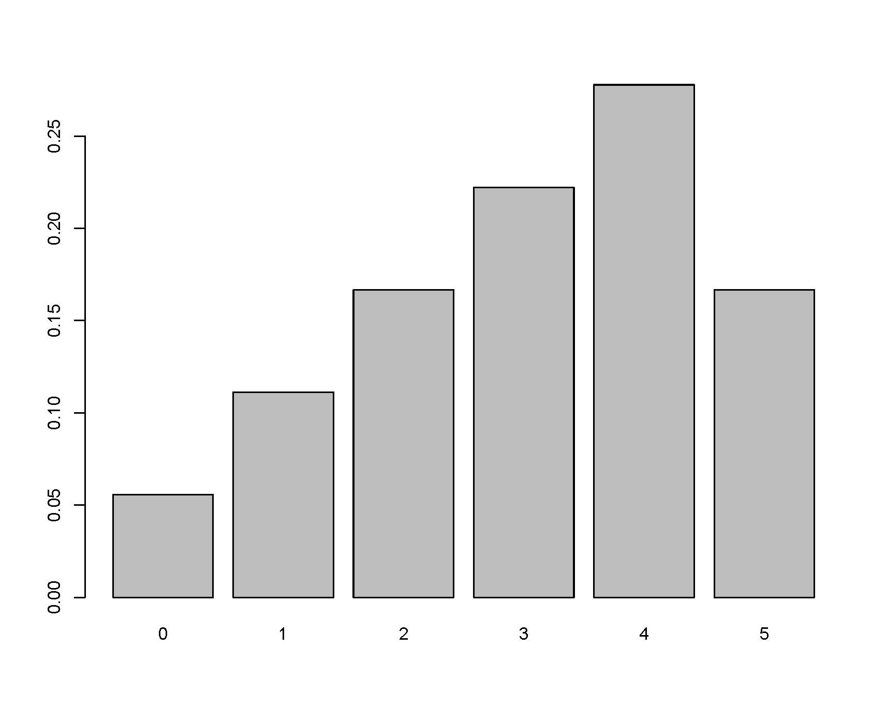 (c) 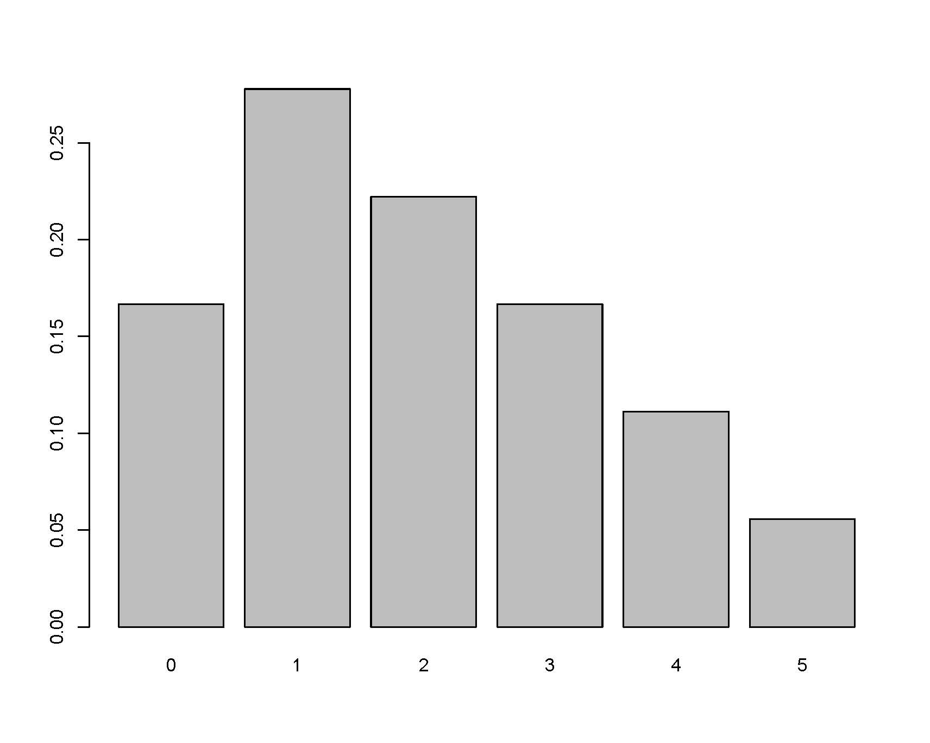

(b) 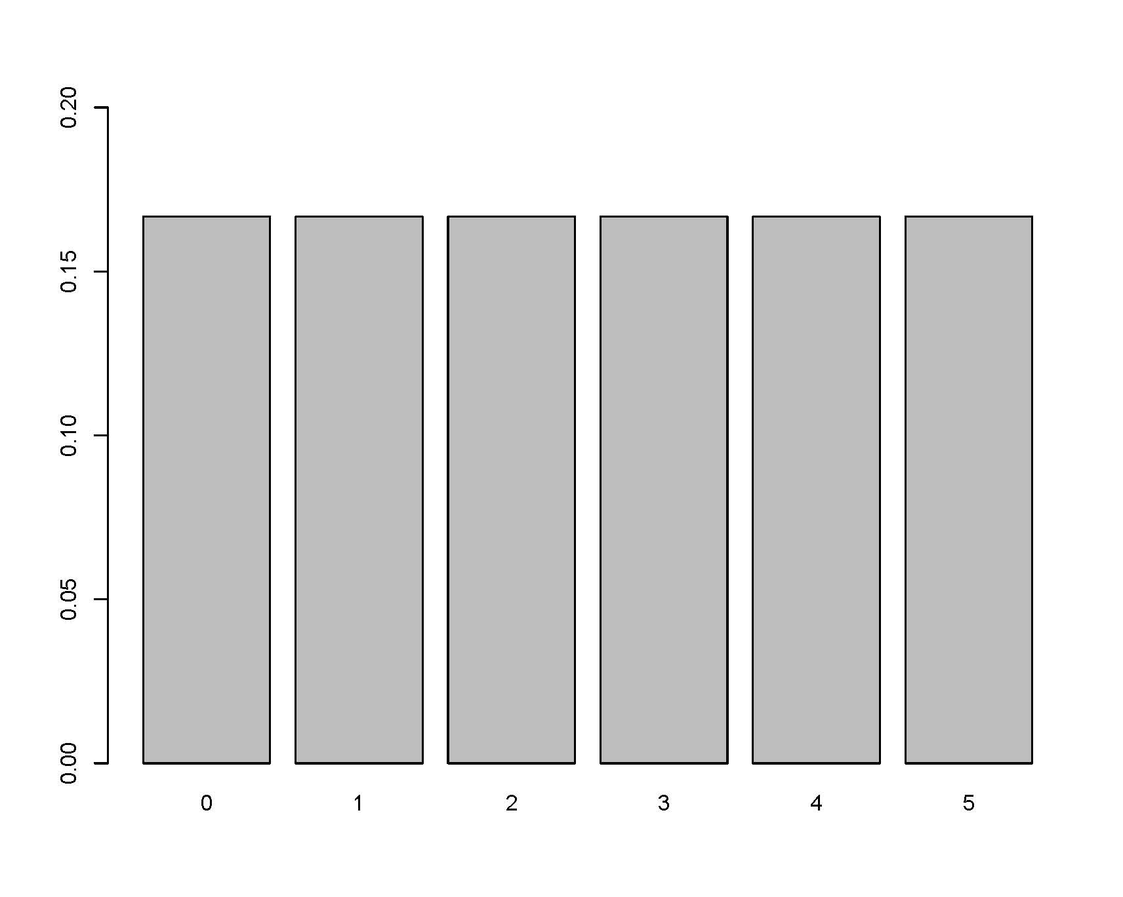

28. Suppose that two balanced dice are rolled, and let X denote the absolute value of the difference between the two numbers that appear. Find the value of c:
X | 0 | 1 | 2 | 3 | 4 | 5
f(x) | c*3 | c*5 | c*4 | c*3 | c*2 | c*1

(a) 1/2
(b) 1/6
(c) 1/9
(d) 1/18
(e) 1/36

29. Suppose that X is distributed according to the pdf f(x) such that:
$f(x) = ce^{-2x} x>0.$
Find the value of c.
a. -2
b. -1/2
c. 1/2
d. 1
e. 2

30. Suppose that X is distributed according to the pdf f(x) such that:
$f(x) = 2e^{-2x} x>0.$
Find P(X >2).
a. $1-e^{4}$
b. $e^{4}$
c. $1-e^{-4}$
d. $e^{-4}$

31. The CDF of a binomial random variable
(e.g., X ~ Bin(47, 0.47) ) is continuous.

(a) TRUE
(b) FALSE

32. For X, a continuous random variable, the pdf, f(x), is defined to be:
(a) The function which gives the probability of X
(b) The function which gives the cumulative probability of X
(c) The function such that when integrated over some interval gives the probability of X in that interval.
(d) The function such that when differentiated gives the probability of X.

33. Suppose that the cdf of a random variable X is as follows:
$$F\left(x\right)= \left\{\begin{aligned}0 x ≤0 \\ \left(\frac{1}{9}\right)x^{2} 0<x ≤3 \\ 1 x>3\end{aligned}\right.$$

What is the pdf of X? (Sketch the pdf.)
What is P(1 < X < 2)?
(a) 1/2
(b) 1/3
(c) 1/4
(d) 2/3

35. Suppose the joint density of X and Y is
$$f_{XY}\left(x,y\right)=cx^{2}y x^{2} ≤y ≤1$$
What is c?
(a) 1
(b) 1/2
(c) 21/4
(d) no clue how to start this problem.
(e) I know how to start the problem, but I get stuck

34. Suppose the joint density of X and Y is
$$f_{XY}\left(x,y\right)=(\frac{21}{4})x^{2}y x^{2} ≤y ≤1$$

What is P(X ≥ Y) ?

(a) 3/20
(b) 1/2
(c) 1/4
(d) No clue how to start this problem
(e) I know how to start the problem, but I get stuck

35. Suppose the joint density of X and Y is
$$f_{XY}\left(x,y\right)=(\frac{21}{4})x^{2}y x^{2} ≤y ≤1$$

What is P(X ≤ 0) ?

(a) 1
(b) 0
(c) 1/2
(d) 21/24 + 1/14
(e) none of these

36. Suppose X and Y have joint cdf:
$$F_{XY}\left(x,y\right)=\left(\frac{1}{16}\right)xy(x+y)$$
Find the joint pdf of X and Y, $f_{XY} (x,y)$:
(a) $\frac{x(x+y)}{16}+ \frac{y(x+y)}{16}$
(b) $\frac{(x+y)}{4}$
(c) $\frac{(x+y)}{8}$
(d) $\frac{(x+y)}{16}$
(e) I don’t know how to do this problem

37. Suppose X and Y have joint cdf:
$$F_{XY}\left(x,y\right)=\left(\frac{1}{16}\right)xy(x+y)$$
Find the marginal cdf of X, $F_{X} (x)$:
(a) $\left(\frac{1}{8}\right)(xy+y^{2})$
(b) $\left(\frac{1}{4}\right)(x+1)$
(c) $\left(\frac{1}{16}\right)(x+x^{2})$
(d) $\left(\frac{1}{8}\right)x (x+2)$
(e) $\left(\frac{1}{8}\right)y(2+y)$

38. Suppose X and Y have joint cdf:
$$F_{XY}\left(x,y\right)=\left(\frac{1}{16}\right)xy(x+y)$$
Find the marginal pdf of X, $f_{X} (x)$:
(a) $\left(\frac{1}{16}\right)(2xy+y^{2})$
(b) $\left(\frac{1}{16}\right)(2xy+x^{2})$
(c) $\left(\frac{1}{8}\right)x(x+2)$
(d) $\left(\frac{1}{4}\right)(x+x^{2})$
(e) $\left(\frac{1}{4}\right)(x+1)$

39. Let f_{XY}(x,y), f_{X}(x) and f_{Y}(y) be joint and marginal pdf functions. The conditional pdf of X given Y=y is:

(a) f_{X}(x)* f_{Y}(y)
(b) f_{X}(x)/ f_{Y}(y)
(c) f_{XY}(x,y)/ f_{X}(x)
(d) f_{XY}(x,y)/f_{Y}(y)

40. Let f_{X|y}(x|y), f_{X}(x) and f_{Y}(y) be conditional and marginal pdf functions. The joint pdf of X and Y is:

(a) f_{X}(x)* f_{Y}(y)
(b) f_{X}(x)/ f_{Y}(y)
(c) f_{X|y}(x|y) * f_{X}(x)
(d) f_{X|y}(x|y) * f_{Y}(y)
(e) f_{X|y}(x|y) / f_{Y}(y)

41. Suppose either of two instruments could be used for making a measurement (X). Instrument 1 has pdf:
f_{X1}(x) = 2x 0 < x < 1
and Instrument 2 has pdf:
f_{X2}(x) = 3x² 0 < x < 1
One instrument is chosen randomly. What is the joint pdf of measurement & choice (Y=1 if first, Y=0 if second):
(a) f_{XY} (x,y) = y (1/2)2x + (1-y) (1/2) 3x²
(a) f_{XY} (x,y) = y 2x + (1-y) 3x²
(c) f_{XY} (x,y) = (1/2) 2x + (1/2) 3x²
(d) f_{XY} (x,y) = y 2x * (1-y) 3x²
(e) f_{XY} (x,y) = y2x + (1-y) 3x²

42. Given 3 RVs: X, Y, Z, you know
$$f_{X|z}(x|z)=f_{X}(x)$$
$$f_{Y|z }\left(y | z\right)=f_{Y}(y)$$
(a) X & Y & Z are definitely independent
(b) X & Y & Z are definitely not independent
(c) we don’t have enough information to determine the independence of X & Y & Z.

43. Find $P\left(X ≤2 \right| Y≤4, Z ≤5)$

(a) $F_{XYZ}(2,4,5)$
(b) $\int_{-∞}^{2}{f_{X|y,z} \left(x\right|4,5)} dx$
(c) $\int_{-∞}^{2}{\frac{f_{X|y,z} \left(x\right|4,5)}{F_{YZ} (4,5)}} dx$
(d) $\frac{F_{XYZ} (2,4,5)}{F_{YZ} (4,5)}$

44. Given the waiting times example (5 people Xi represents the time to serve customer i), what is the conditional density of X1 given the other 4 waiting times?

(a) $\frac{f_{X1}(x1)}{f_{X1, X2,X3, X4, X5} (x1, x2, x3, x4, x5)}$
(b) $\frac{f_{X1}(x1)}{f_{X2,X3, X4, X5} (x2, x3, x4, x5)}$
(c) $\frac{ f_{X2,X3, X4, X5} (x2, x3, x4, x5)}{f_{X1}\left(x1\right)}$
(d) $\frac{ f_{X1, X2,X3, X4, X5} (x1,x2, x3, x4, x5)}{f_{X1}\left(x1\right)}$
(e) $\frac{ f_{X1, X2,X3, X4, X5} (x1,x2, x3, x4, x5)}{f_{X2,X3, X4, X5} (x2, x3, x4, x5)}$

45. Given the waiting times example, what is the marginal density of X1?
(a) $\iiint_{-∞}^{∞}{f_{X1, X2,X3, X4, X5} \left(x1,x2, x3, x4, x5\right) dx1 dx2 dx3 dx4 dx5}$

(b) $\iiint_{-∞}^{∞}{f_{X1, X2,X3, X4, X5} \left(x1,x2, x3, x4, x5\right) dx2 dx3 dx4 dx5}$

(c) $\iiint_{-∞}^{∞}{f_{ X2,X3, X4, X5} \left(x2, x3, x4, x5\right) dx1 dx2 dx3 dx4 dx5}$

(d) $\iiint_{-∞}^{∞}{f_{ X2,X3, X4, X5} \left(x2, x3, x4, x5\right) dx2 dx3 dx4 dx5}$

46. X ~ U[0,1], gives Y = X², $f_{Y}\left(y\right)= \frac{1}{2\sqrt{y}} 0 ≤y≤1$

What if X ~ U[-1,1], what is the pdf of Y = X² ?

(a) $f_{Y}\left(y\right)= \frac{1}{2\sqrt{y}} 0 ≤y≤1$
(b) $f_{Y}\left(y\right)= \frac{1}{2\sqrt{|y|}} -1 ≤y≤1$
(c) $f_{Y}\left(y\right)= \frac{1}{\sqrt{y}} 0 ≤y≤1$
(d) $f_{Y}\left(y\right)= \frac{1}{2y^{2}} -1 ≤y≤1$

47. Let X = number of buses that arrive in a given hour.
I’m more interested in Y = 47*X, the number of seats available for passengers in a given hour.

Can I use the formula (change of variable theorem) for finding the pdf of Y?

(a) Yes, because X is continuous
(b) No, because X is not continuous
(c) Yes, because “h” is strictly increasing
(d) No, because “h” is not strictly increasing

47. At time=0, v₀ organisms are put in a large tank of water, where X is the (unknown) rate of growth:
v₀(t) = Xv(t) → v(t) = v₀e^{Xt}
Suppose X has a pdf:
f_{X}(x) = 3(1 - x)² 0 < x < 1
What is the density of Y = v₀e^{Xt}? To be specific, if v₀ = 10, what is the distribution of the organisms at t = 5?
A. f_{Y} (y) = e^{15(1-y)^2} 10 < y < 10e⁵.
B. f_{Y} (y) = 3(1 - ln(y/10) / 5)² / (5y) 0 < y < 1.
C. f_{Y} (y) = 3(1 - ln(y/10) / 5)² / (5y) 10 < y < 10e⁵

48. If $F_{X1, X2, X3, X4} (x1, x2, x3, x4)$ is the joint CDF, we know:
(a) $0 ≤F_{X1, X2, X3, X4} \left(x1, x2, x3, x4\right)≤∞$
(b) $0 ≤F_{X1, X2, X3, X4} \left(x1, x2, x3, x4\right)≤1$
(c) $-∞ ≤F_{X1, X2, X3, X4} \left(x1, x2, x3, x4\right)≤∞$

49. If $f_{X1, X2, X3, X4} (x1, x2, x3, x4)$ is the joint PDF, we know:
(a) $0 ≤f_{X1, X2, X3, X4} \left(x1, x2, x3, x4\right)≤∞$
(b) $0 ≤f_{X1, X2, X3, X4} \left(x1, x2, x3, x4\right)≤1$
(c) $-∞ ≤f_{X1, X2, X3, X4} \left(x1, x2, x3, x4\right)≤∞$

50. If (X,Y) is a bivariate discrete random variable on the natural numbers ( $\left(X,Y\right)∈N^{2}$), the number of values which Z = X-Y can take on is:
(a) infinite & non-negative
(b) infinite & positive or negative
(c) finite & positive
(d) finite & positive or negative
(e) none of the above

51. Consider a random sample of n continuous observations (from the same distribution, F_{X}).
Find: P(smallest observation ≤ y)

(a) (F_{X}(y) )^{n}
(b) (1 - F_{X}(y) )^{n}
(c) n*(F_{X}(y) )
(d) 1 - (1 - F_{X}(y) )^{n}
(e) (1 - F_{X}(x) )^{n}

52. Consider a random sample of n continuous observations (from the same distribution, F_{X}).

Find: P(largest observation ≤ y)

(a) (F_{X}(y) )^{n}
(b) (1 - F_{X}(y) )^{n}
(c) n*(F_{X}(y) )
(d) 1 - (1 - F_{X}(y) )^{n}
(e) (F_{X}(x) )^{n}

53. Suppose that the probability of badminton player winning a point is 0.75 if he has won the preceding point, and 0.42 if he has lost the preceding point. Suppose X_{i} =1 if the player wins the i^{th} point and X_{i} = 0 if the player loses the i^{th} point.

The probability that he loses the third point if he has won the first point is closest to:
(a) 0.3325
(b) 0.6675
(c) 0.3597
(d) 0.4414
(e) 0.3957

54. Consider the matrices:
The matrix that could be a transition matrix for a Markov chain is:
(a) U
(b) V
(c) W
(d) X
(e) Y

55. Occupied phone lines. If all five lines are currently in use, what is the probability that exactly 4 will be in use at the next time step?
- 0.1
- 0.2
- 0.3
- 0.4
- 0.9

56. Occupied phone lines. If no lines are currently in use, what is the probability that at least one will be in use at the next time step?
- 0.1
- 0.2
- 0.3
- 0.4
- 0.9
57. Occupied phone lines. If two lines are currently in use ($b_{2}$), what is the probability that one line will be in use ($b_{1}$) in TWO time steps?
- 0.1
- 0.2
- 0.3
- 0.4
- 0.9

55. A Markov chain is defined by a transition matrix
T = and an initial state matrix v = ^{t}.
For this Markov chain, v₁ (probability of being in each state at time 1) is closest to:
(a) ^{t}
(b) ^{t}
(c) ^{t}
(d) ^{t}
(e) ^{t}

56. A Markov chain is defined by a transition matrix
T = and an initial state matrix v = ^{t}.
For this Markov chain, v₂ is closest to:
(a) ^{t}
(b) ^{t}
(c) ^{t}
(d) ^{t}
(e) ^{t}

57. Label the following as Bernoulli or Markov sequences or neither:
(a) A basketball player has a probability of 0.7 of scoring a goal on each of 10 attempts.
(b) A basketball player has 10 attempts at goal where she has a probability of 0.7 of scoring a goal if she has scored a goal on the previous attempt, and a probability of 0.6 of scoring a goal if she has missed the goal on the previous attempt.
(c) The probability that any child born into a family with five children is male is 0.52.
(d) The probability that it will rain one day given that it rained the previous day is 0.6, and if it has not rained the previous day the probability of rain is 0.2.
(e) Three balls are drawn without replacement from a jar containing five red and five black balls and the probability of drawing a black ball each time determined.

(a. B, b. M, c. B, d. M, e. N)

58. Suppose a fair die is thrown many times. What is the average of the numbers that you see?

a. 3
b. 3.5
c. 4
d. > 4

59. Suppose a die has four faces with a 6 on them, and two faces with a 2 on them. The die is thrown many times. What is the average of the numbers that you see?
a. 3
b. 3.5
c. 4
d. > 4

60. Suppose the amount of time, in weeks, you remember what you learned in this class is a random variable with density function:

$$f\left(x\right)= .01 e^{-x/100} x>0$$
What is the expected amount of time you'll remember the material in this class?
a. 50 weeks
b. 100 weeks
c. 150 weeks

61. A random variable X has a Bernoulli Distribution with parameter p if X can be either 0 or 1, and P(X = 1) = p.

What is E[X]?

a. p
b. (1-p)
c. p(1-p)
d. not enough information

62. The Cauchy density is:
$$f\left(x\right)=\frac{1}{π\left(1+ x^{2}\right)} -∞<x< ∞$$

What is E[X]?

a. 0
b. 0.3
c. infinity
d. none of these

63. X ~ U[0,1] , let Y = e^{X}. Find: E[e^{X}]

(a) e^{0.5}
(b) e¹
(c) e – 1
(d) 1

64. Suppose a point is chosen at random in the unit square. Find its expected squared distance from the origin.

(a) 0.5
(b) π/4
(c) 2/3

65. The expected value of X:
(a) is always positive
(b) is always a possible value for X (i.e., is one of the values within the support of X)
(c) is a parameter
(d) some of the above
(e) all of the above

66. Let X be distributed on the interval [0,10], find the expected value and variance of X.
(a) E[X] = 5, Var(X) = 5
(b) E[X] = 5, Var(X) = 2.897
(c) E[X] = 5, Var(X) = 8$\frac{1}{3}$

67. Y ~ Bin(47,.9) E(Y) = ?

(a) np (= 47*0.9)
(b) n(1-p) (=47*0.1)
(c) p (=0.1)
(d) np(1-p) (=47*0.9*0.1)

68. Y ~ Bin(47,.9) Var(Y) = ?
(a) np² ( = 47 * 0.9²)
(b) np² - n²p² ( = 47 * 0.9²- 47² * 0.9²)
(c) np(1-p) ( = 47*0.9 * 0.1)

70. ψ(t) = E[ e^{tX}], ψ(0) = ?

(a) 1
(b) 0
(c) depends on the distribution of X

71. f(x) = e^{-x} x ≥ 0, ψ(t) = E[ e^{tX}] = ?

(a) 1/t
(b) 1/(t-1)
(c) exists for all t > 0
(d) exists for all t < 1

72. f(x) = e^{-x} x ≥ 0, ψ(t) = E[ e^{tX}] = 1/(1-t), Var(X) = ?

(a) 0
(b) 1
(c) 2

73. Consider a random sample, X1, X2, … Xn. What is E[$\prod_{i=1}^{n}{X_{i}^{2}}$] ?

(a) E[$\prod_{i=1}^{n}{X_{i}}$]²
(b) [$\prod_{i=1}^{n}{E\left[X_{i}^{2}\right] }$]
(c) [$\prod_{i=1}^{n}{{{E[X}_{i}]}^{2}}]$
(d) (E[$\prod_{i=1}^{n}{X_{i}}$] )²

74. Suppose the pdf of X is:

f(x) = 4x³ 0 ≤ x ≤ 1

The median of X is
- 4(1/2)³
- (1/2)⁴
- (1/2)^{1/4}
- (4/5)(1/2)⁵
- None of these

75. Suppose the pdf of X is:
$$f\left(x\right)= \left\{\begin{aligned}\frac{1}{2} 0 ≤x ≤1 \\ 1 2.5 ≤x ≤3 \\ 0 else\end{aligned}\right.$$

The median of X is
- 1
- 1.75
- 2.5
- X has infinitely many medians

76. If X and Y are independent, then Cov(X,Y) =

(a) 1
(b) 0
(c) varies

77. Suppose X = -1, 0, 1 with equal probability. Y = X²

Find Cov(X,Y).

(a) 1
(b) 0
(c) -1
(d) none of these

78. Let X and Y have the joint distribution:

f(x,y) = x + y 0 ≤ x ≤ 1, 0 ≤ y ≤ 1

Are X and Y independent?

(a) Yes
(b) No

79. True or False: ρ(X,Y) ≤ 1
(a) True
(b) False

80. If ρ(X,Y) = -1, then

(a) $Y = a - \frac{σ_{x}}{σ_{y}} X$
(b) Y = -X
(c) $Y = -a - \frac{σ_{x}}{σ_{y}} X$

81. Consider the following dice game: players 1 and 2 roll in turn a pair of dice (they each roll a pair). Then the bank rolls a pair of dice. If a player's roll is strictly higher than the bank's roll, the player wins.

Are the two player's winnings correlated?

(a) Yes, they are negatively correlated.
(b) Yes, they are positively correlated.
(c) No, they are not correlated.

82. Let X and Y denote the values of two stocks at the end of a five-year period. X is uniformly distributed on the interval (0, 12) . Given X = x, Y is uniformly distributed on the interval (0, x).
Are the two stock values correlated?

(a) Yes, they are negatively correlated.
(b) Yes, they are positively correlated.
(c) No, they are not correlated.

Suppose that we record the midterm exam score and the final exam score for every student in a class. What would the value of the correlation coefficient be if every student in the class scored ten points higher on the final than on the midterm:
(a) r = -1
(b) -1 < r < 0
(c) r = 0
(d) 0 < r < 1
(e) r = 1

Suppose that we record the midterm exam score and the final exam score for every student in a class. What would the value of the correlation coefficient be if every student in the class scored five points lower on the final than on the midterm:
(a) r = -1
(b) -1 < r < 0
(c) r = 0
(d) 0 < r < 1
(e) r = 1

83. If we repeatedly flip a coin 16 times, what percent of the time will the simulation flip exactly 8 heads?
- 0-15%
- 16-30%
- 31-49%
- 50%
- 51-100%

83. What if we flipped a coin 160 times? What percent of the time will the simulation flip exactly 80 heads?
- 0-15%
- 16-30%
- 31-49%
- 50%
- 51-100%

84. X ~ Bin(n,p). $E\left[e^{tX}\right]=$

(a) $\sum_{k=1}^{n}{ \left({n \atop k}\right) (e^{t}{p)}^{k}{(1-p)}^{n-k}}$
(b) $\sum_{k=1}^{n}{ \left({n \atop k}\right) e^{tk}({p)}^{k}{(1-p)}^{n-k}}$
(c) $\sum_{k=0}^{n}{ \left({n \atop k}\right) ({p)}^{k}{(e^{t}(1-p))}^{n-k}}$
(d) $\sum_{k=0}^{n}{ \left({n \atop k}\right) (e^{t}{p)}^{k}{(1-p)}^{n-k}}$
(e) $\sum_{k=0}^{n}{ \left({n \atop k}\right) e^{tX}({p)}^{k}{(1-p)}^{n-k}}$

85. $X_{i}$ ~ Bernoulli (p) Find MGF of $\sum_{i=1}^{n}{X_{i}}$

- $p e^{t}+\left(1-p\right)$
- $(1-p) e^{t}+p$
- ${(p e^{t}+\left(1-p\right))}^{n}$
- ${(p e^{t}+\left(1-p\right))}^{t}$
- ${(p e^{t/n}+\left(1-p\right))}^{n}$

86. $X_{i}$ ~ Bernoulli (p) Find MGF of $\hat{p}= \sum{X_{i}/n}$

- $p e^{t}+\left(1-p\right)$
- $(1-p) e^{t}+p$
- ${(p e^{t}+\left(1-p\right))}^{n}$
- ${(p e^{t}+\left(1-p\right))}^{t}$
- ${(p e^{t/n}+\left(1-p\right))}^{n}$

85. Let X ~ Poisson such that P(X=1) = P(X=2). The rate (λ) of the Poisson distribution is:

(a) λ = 0.5
(b) λ = 1
(c) λ = 2
(d) λ = 5
(e) λ does not exist

86. The standard deviation of a Poisson distribution is 2. What is its mean?

(a) 1
(b) 2
(c) 4
(d) 8

87. The variance of a binomial distribution is _______ its mean.

(a) smaller than
(b) the same as
(c) bigger than

88. The variance of a Poisson distribution is _______ its mean.

(a) smaller than
(b) the same as
(c) bigger than

89. If X~Poisson (λ), an approximately equivalent distribution is:
(a) Bernoulli (λ/n)
(b) Bernoulli (λ*n)
(c) Binomial (n, λ/n)
(d) Binomial (n, λ*n)

p.s. What is n???

90. If X ~ N(8, 64 (var) ), then the standard normal deviate is:

(a) Z = (X-64)/8
(b) Z = (X-8)/64
(c) Z = (X-8)/8
(d) Z = (8-X)/8

91. Which of the transformations above give normal random variables? If X ~ N(8, 64 (var) ):

() Z = (X-64)/8
(a) Z = (X-8)/64
(b) Z = (X-8)/8
(c) Z = (8-X)/8
(d) all
(e) some

92. The variance of the sample mean is:
(a) larger than the variance of the data
(b) the same as the variance of the data
(c) smaller than the variance of the data
(d) unrelated to the variance of the data

93. Suppose that the heights of men and women in a certain population are distributed as
N(68, 3^2 = 9) and N(65, 1), respectively.
If one man and one woman are randomly selected, what is the probability that the woman will be taller than the man?
(a) 0-0.1
(b) 0.1-0.4
(c) 0.4 – 0.6
(d) 0.6 – 0.9
(e) 0.9 – 1

94. Let X and Y be independent N(5, σ² = 4) random variables. Using Markov’s Inequality, what can we say about
P(X+Y ≥ 12) ?
(a) ≤ 1
(b) ≤ 0.5
(c) ≥ 1
(d) ≥ 0.5
(e) nothing

95. Let X and Y be independent N(5, σ² = 4) random variables. Using Chebyshev’s Inequality, what can we say about
P(|X+Y – 10 | ≥ 2) ?
(a) ≤ 1
(b) ≤ 0.5
(c) ≥ 1
(d) ≥ 0.5
(e) nothing

96. Let X and Y be independent N(5, σ² = 4) random variables. Using Chebyshev’s Inequality, what can we say about
P(|X+Y – 10 | ≥ 3) ?
(a) ≤ 1
(b) ≤ 8/9
(c) ≥ 1
(d) ≥ 8/9
(e) nothing

97. Suppose you flip a coin n times. The law of large numbers will allow you to put bounds on the probable values of:
(a) each coin
(b) number of heads
(c) proportion of heads
(d) all of the above

98. Suppose you flip a coin n times. What can you say about the variance of the proportion of heads vs. the variance of the number of heads?
(a) Var(num heads) > Var(prop heads)
(b) Var(num heads) < Var(prop heads)
(c) Var(num heads) = Var(prop heads)
(d) Depends on the probability of heads
(e) Depends on the sample size, n
99. The (sampling) distribution of the mean will be
(a) centered below the data distribution
(b) centered at the same place as the data distribution
(c) centered above the data distribution
(d) unrelated to the center of the data distribution

100. The (sampling) distribution of the mean will be
(a) less variable than the data distribution
(b) the same variability as the data distribution
(c) more variable than the data distribution
(d) unrelated to the variability of the data distribution

101. When the population is skewed right, the sampling distribution for the sample mean will be
(a) always skewed right
(b) skewed right if n is big enough
(c) always normal
(d) normal if n is big enough

102. Suppose the moment generating function for n iid random variables, Yi is ϕ(t).
What is the m.g.f. of $\frac{1}{\sqrt{n}}\sum_{i=1}^{n}{Y_{i}}$ ?

(a) n ϕ(t/$\sqrt{n}$)
(b) n ϕ(t)/$\sqrt{n}$
(c) $({φ(t/\sqrt{n}))}^{n}$

103. To prove the CLT, we need to show that
[for L(*) = ln(ϕ(*)) ]:

(a) L(t) → t^2/2
(b) L (t/$\sqrt{n}$) → t^2/2
(c) L (t) → n (t/$\sqrt{n}$)^2/2
(d) none of these

