Statistical Analysis of Genetic Data
Math 155: Spring 2008
Jo Hardin
Partitioning Around Medoids

library(cluster)

de.p.pam2 <- pam(y.de.pear,k=2)
de.s.pam2 <- pam(y.de.sp,k=2)

summary(de.p.pam2)
summary(de.s.pam2)

de.p.pam2.grp <- de.p.pam2$clustering
de.s.pam2.grp <- de.s.pam2$clustering

table(de.p.pam2.grp,de.s.pam2.grp)
# note that labels don't matter, it's groupings we look for

sil.width.p <- c()
for (i in 2:10){
sil.width.p <- c(sil.width.p,pam(y.de.pear,k=i)$silinfo$avg.width)}

win.graph()
plot(2:10,sil.width.p,xlab="# clusters", ylab="average silhouette width: Pearson",pch=18)

sil.width.s <- c()
for (i in 2:10){
sil.width.s <- c(sil.width.s,pam(y.de.sp,k=i)$silinfo$avg.width)}

win.graph()
plot(2:10,sil.width.s,xlab="# clusters", ylab="average silhouette width: Spearman",pch=18)

table(de.p.pam2.grp,pam(y.de.sp,k=4)$clustering)

adjrand(de.p.pam2.grp,pam(y.de.sp,k=4)$clustering)
adjrand(de.p.pam2.grp,de.s.pam2.grp)
> summary(de.p.pam2)

Medoids:
ID
[1,] "10" "YJL091C"
[2,] "13" "YJR119C"

Clustering vector:
SCEI AI2 BUD3 YNR067C YBR178W GAA1 UTR2
1 1 1 1 1 1 1
PRC1 IST3 YJL091C RRN7 DRS1 YJR119C HSP12
1 1 1 2 2 2 2
YEL007W YJR129C RGP1 DFG16 MRK1 YBR147W
2 2 2 2 2 2

Objective function:
build swap
0.4341120 0.3612033

Numerical information per cluster:
size max_diss av_diss diameter separation
[1,] 10 0.5124258 0.3081498 1.057985 0.4381411
[2,] 10 0.7022119 0.4142567 1.354385 0.4381411

Isolated clusters:
L-clusters: character(0)
L*-clusters: character(0)

Silhouette plot information:
 | cluster | neighbor | sil_width
YJL091C | 1 | 2 | 0.76262
AI2 | 1 | 2 | 0.722675
IST3 | 1 | 2 | 0.694895
PRC1 | 1 | 2 | 0.694012
GAA1 | 1 | 2 | 0.684048
UTR2 | 1 | 2 | 0.636536
YBR178W | 1 | 2 | 0.57038
YNR067C | 1 | 2 | 0.510527
SCEI | 1 | 2 | 0.496701
BUD3 | 1 | 2 | 0.428641
YJR119C | 2 | 1 | 0.672815
YEL007W | 2 | 1 | 0.624587
RRN7 | 2 | 1 | 0.599199
RGP1 | 2 | 1 | 0.589715
YBR147W | 2 | 1 | 0.510349
MRK1 | 2 | 1 | 0.499586
HSP12 | 2 | 1 | 0.446832
DRS1 | 2 | 1 | 0.431045
YJR129C | 2 | 1 | 0.377906
DFG16 | 2 | 1 | 0.327074

Average silhouette width per cluster:
[1] 0.6201034 0.5079108

Average silhouette width of total data set:
[1] 0.5640071

Available components:
[1] "medoids" "id.med" "clustering" "objective"
[5] "isolation" "clusinfo" "silinfo" "diss"
[9] "call"

> summary(de.s.pam2)

Medoids:
ID
[1,] "19" "MRK1"
[2,] "6" "GAA1"

Clustering vector:
SCEI AI2 BUD3 YNR067C YBR178W GAA1 UTR2
1 2 2 2 2 2 2
PRC1 IST3 YJL091C RRN7 DRS1 YJR119C HSP12
2 2 2 2 2 1 1
YEL007W YJR129C RGP1 DFG16 MRK1 YBR147W
2 2 1 2 1 1

Objective function:
build swap
0.6047270 0.5533779

Numerical information per cluster:
size max_diss av_diss diameter separation
[1,] 6 0.8805339 0.4281523 0.9481646 0.5384236
[2,] 14 0.9193548 0.6070460 1.5271261 0.5384236

Isolated clusters:
L-clusters: character(0)
L*-clusters: character(0)

Silhouette plot information:
 | cluster | neighbor | sil_width
MRK1 | 1 | 2 | 0.614259
HSP12 | 1 | 2 | 0.599887
YBR147W | 1 | 2 | 0.5168
RGP1 | 1 | 2 | 0.469661
YJR119C | 1 | 2 | 0.337222
SCEI | 1 | 2 | 0.002399
UTR2 | 2 | 1 | 0.567723
GAA1 | 2 | 1 | 0.561622
YNR067C | 2 | 1 | 0.541635
YJL091C | 2 | 1 | 0.498872
BUD3 | 2 | 1 | 0.329581
YJR129C | 2 | 1 | 0.27942
DRS1 | 2 | 1 | 0.26894
IST3 | 2 | 1 | 0.174014
AI2 | 2 | 1 | 0.139442
YEL007W | 2 | 1 | 0.065159
PRC1 | 2 | 1 | 0.05097
RRN7 | 2 | 1 | 0.048543
YBR178W | 2 | 1 | -0.03527
DFG16 | 2 | 1 | -0.08449

Average silhouette width per cluster:
[1] 0.4233716 0.2432970
Average silhouette width of total data set:
[1] 0.2973194

Available components:
[1] "medoids" "id.med" "clustering" "objective"
[5] "isolation" "clusinfo" "silinfo" "diss"
[9] "call"

> de.p.pam2.grp <- de.p.pam2$clustering
> de.s.pam2.grp <- de.s.pam2$clustering

> table(de.p.pam2.grp,de.s.pam2.grp)
de.s.pam2.grp
de.p.pam2.grp 1 2
1 1 9
2 5 5
> # note that labels don't matter, it's groupings we look for

> win.graph()
> plot(2:10,sil.width.p,xlab="# clusters", ylab="average silhouette width: Pearson",
pch=18)
> win.graph()
> plot(2:10,sil.width.s,xlab="# clusters", ylab="average silhouette width: Spearman",
pch=18)

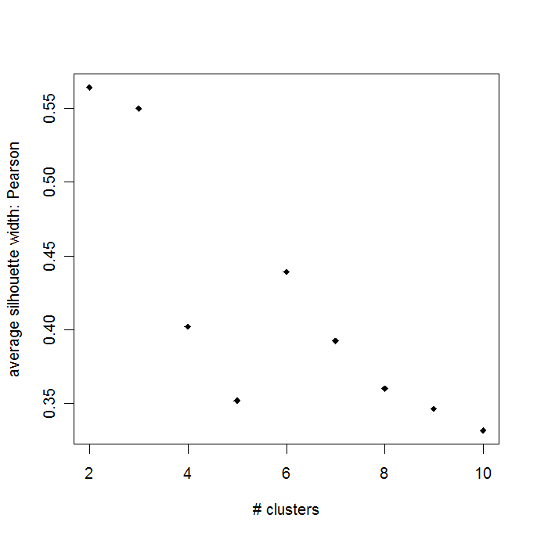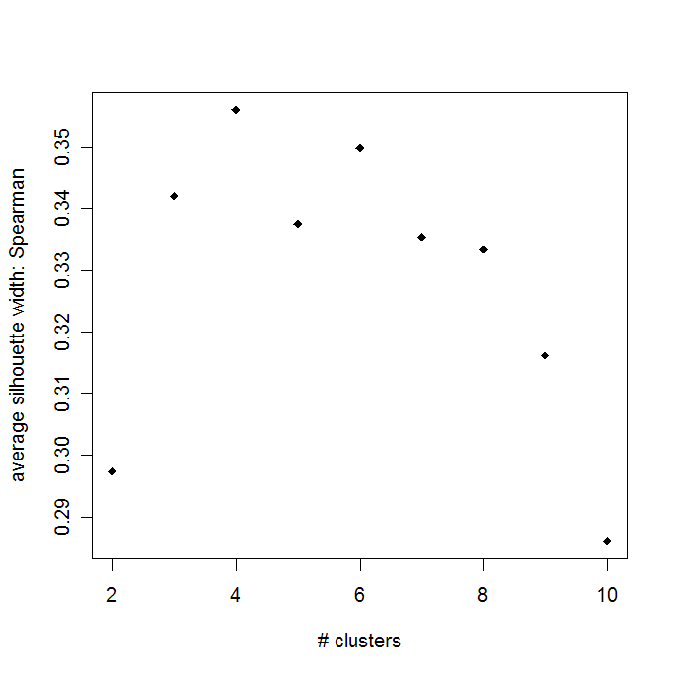

> table(de.p.pam2.grp,pam(y.de.sp,k=4)$clustering)

de.p.pam2.grp 1 2 3 4
1 5 5 0 0
2 0 0 5 5

> adjrand(de.p.pam2.grp,pam(y.de.sp,k=4)$clustering)
[1] 0.4571429

> adjrand(de.p.pam2.grp,de.s.pam2.grp)
[1] 0.1211454

