Unit 3 Homework 2 Solutions

1. A plot of lnP vs 1/T will yield the slope $−\frac{Δ_{\text{vap}}{\bar{H}}^{ο}}{R}$= -5291.5
$Δ_{\text{vap}}{\bar{H}}^{ο}$= 44.0 kJ/mol

2. Start from the Clapeyron Equation since this involves the solid-liquid coexistence curve: $\frac{\text{dP}}{\text{dT}}=\frac{Δ_{\text{trs}}\bar{H}}{{TΔ}_{\text{trs}}\bar{V}}$
Since we want the dependence of temperature on pressure, use the equation: $\frac{\text{dT}}{\text{dP}}=\frac{{TΔ}_{\text{trs}}\bar{V}}{Δ_{\text{trs}}\bar{H}}$
$$\frac{\text{dT}}{\text{dP}}=\frac{(\text{273}\text{.}2)(−1\text{.}\text{63}{{\text{cm}}^{3}}/{\text{mol}})}{\text{6009}\text{.}5J/{\text{mol}}}{\left(\frac{\text{10}\text{cm}}{1\text{dm}}\right)}^{3}\left(\frac{8\text{.}\text{314}J/{K^{−1}}{\text{mol}}^{−1}}{0\text{.}\text{08206}{\text{dm}}^{3}⋅\text{atm}⋅K^{−1}{\text{mol}}^{−1}}\right)$$
$\frac{ΔT}{ΔP}=$-0.00751 K atm⁻¹
$$ΔP=\frac{ΔT}{−0\text{.}\text{00751}K⋅\text{atm}}=\frac{−1K}{−0\text{.}\text{00751}K⋅\text{atm}}=\text{133}\text{atm}$$
P_{f} – 1 = 133 atm
P_{f} = 134 atm

You can also integrate the equation to get $\text{ln}\frac{T_{2}}{T_{1}}=\left(\frac{ΔV}{ΔH}\right)\left(P_{2}−P_{1}\right)$ and solve for pressure.

3. (a)
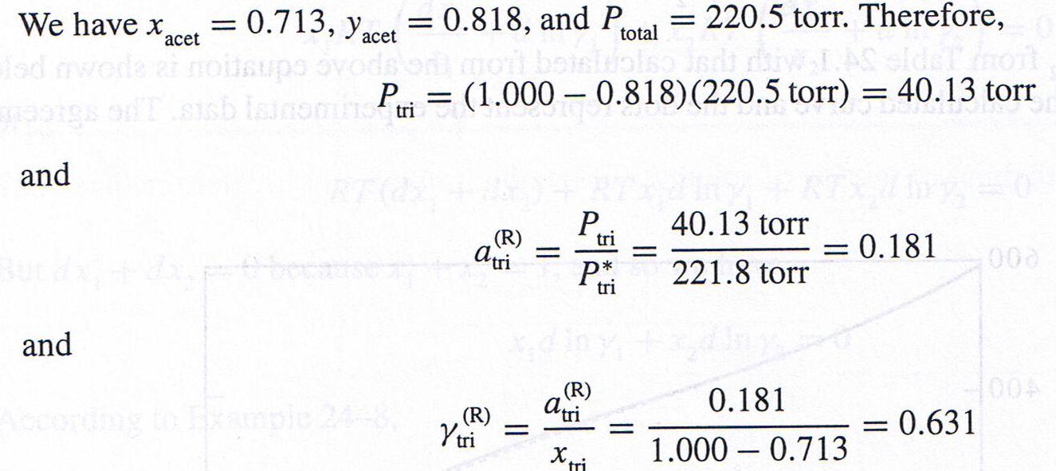

(b)

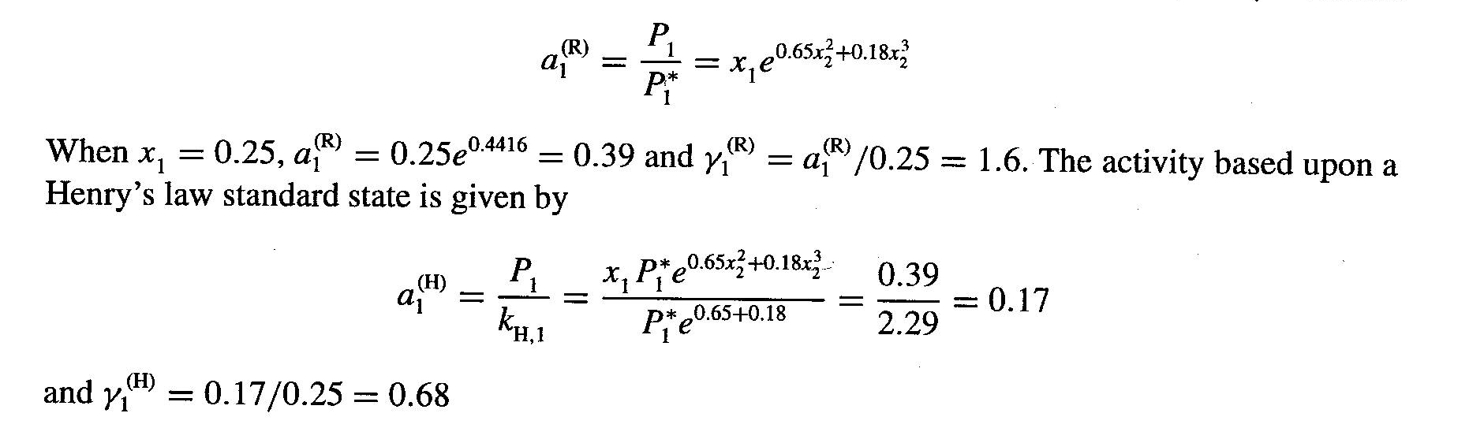
4. The plot of φ vs. m is shown on the right.

$$\frac{φ−1}{m}=0\text{.}\text{0002}m^{3}−0\text{.}\text{004}m^{2}+0\text{.}\text{0166}m+0\text{.}\text{0754}$$

Then integrate from m = 0 to m = 2 molal.

$$\int{\left(\frac{φ−1}{m}\right)\text{dm}=0\text{.}\text{0002}m^{3}−0\text{.}\text{004}m^{2}+0\text{.}\text{0166}m+0\text{.}\text{0754}}={\left|\frac{0\text{.}\text{0002}m^{4}}{4}−\frac{0\text{.}\text{004}m^{3}}{3}+\frac{0\text{.}\text{0166}m^{2}}{2}+0\text{.}\text{0754}m\right|}_{0}^{2}$$
$$=0\text{.}\text{0008}−0\text{.}\text{0107}+0\text{.}\text{0332}+0\text{.}\text{1508}=0\text{.}\text{1741}$$

Now solve $\text{ln}γ=φ−1+\int{\frac{φ−1}{m}}\text{dm}$ to get $\text{ln}γ=(0\text{.}\text{0032}−0\text{.}\text{032}+0\text{.}\text{0664}+0\text{.}\text{1508})+0\text{.}\text{1741}=0\text{.}\text{3625}$
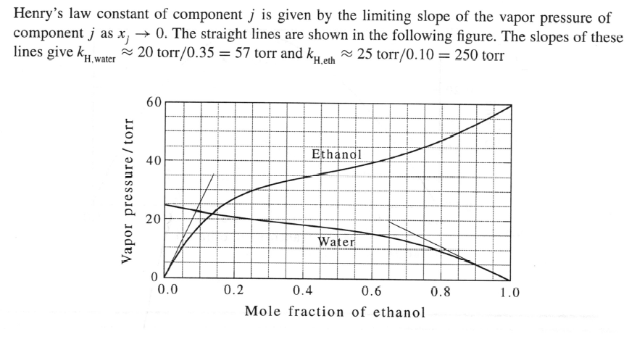
24-50
24.53

