**Unit 2, Homework No. 1: Chemical Equilibria – SOLUTIONS**

1.

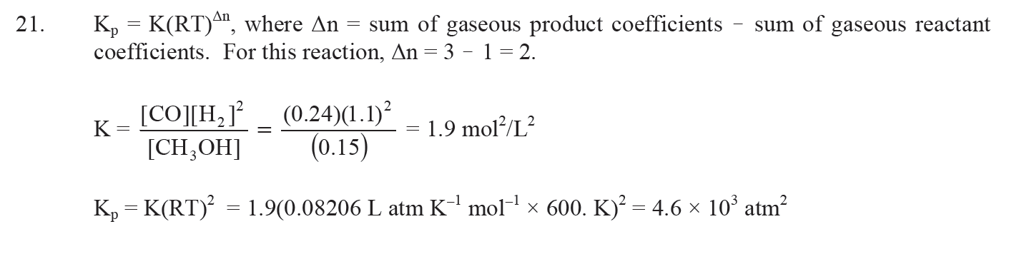

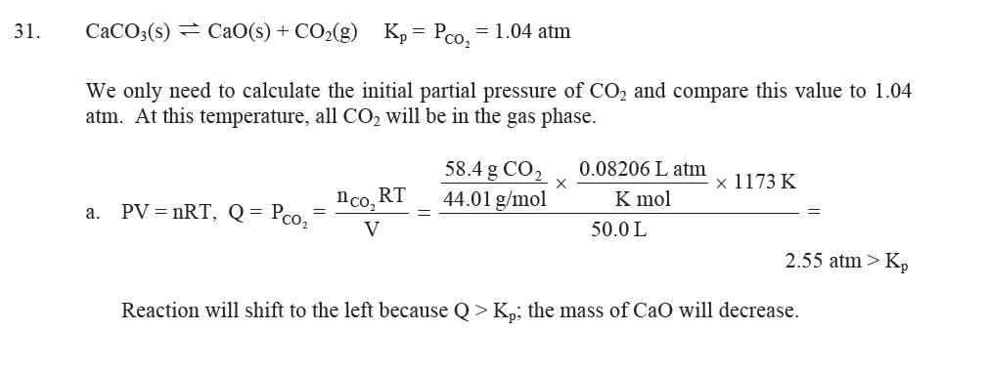

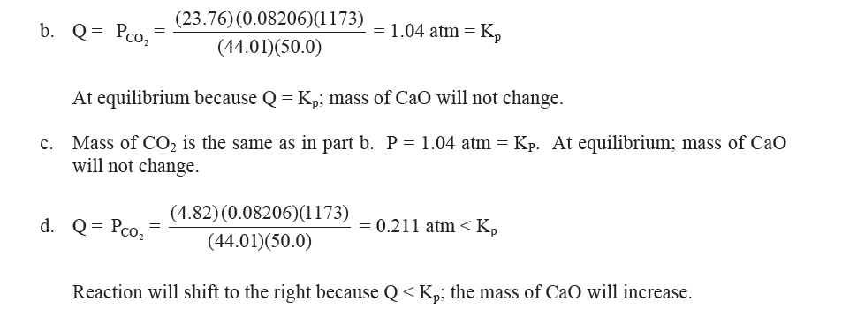

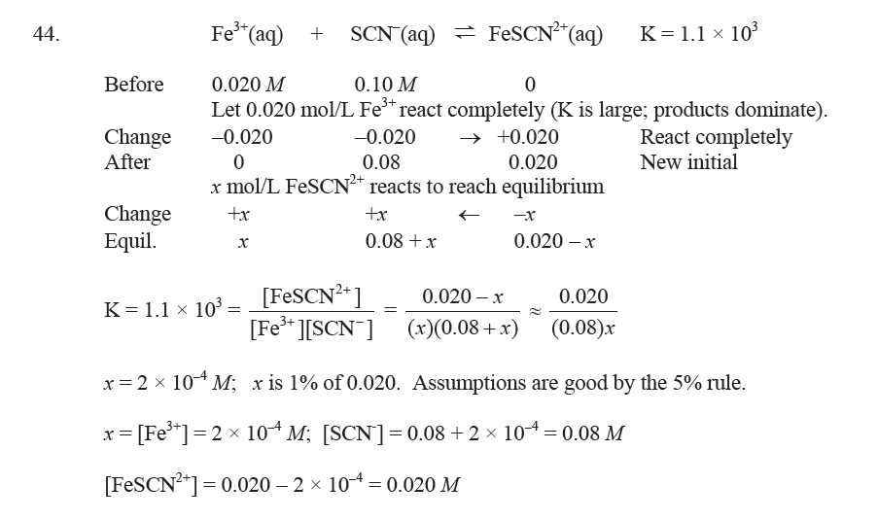

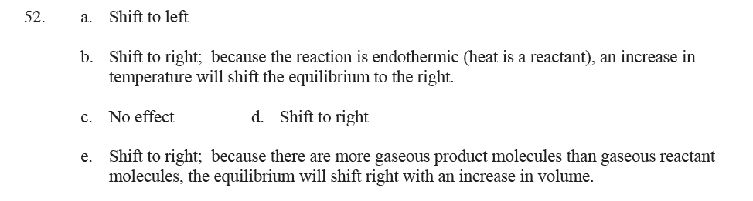

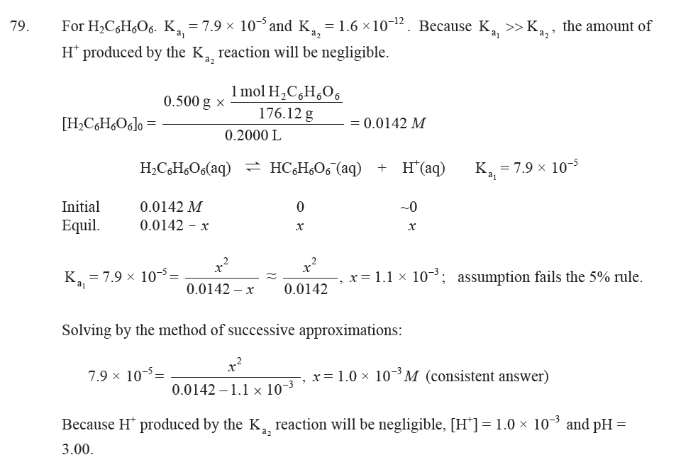

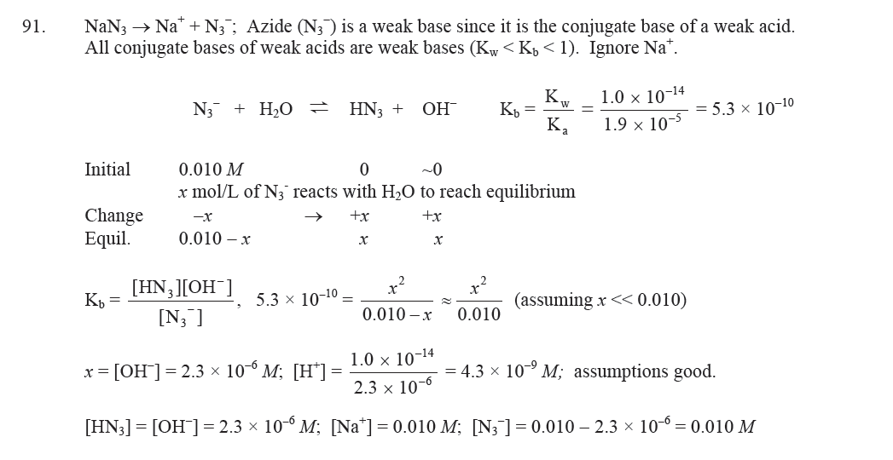

3 .

4. Calculate the initial partial pressure of ammonia (assuming it to behave like an ideal gas).



NH4HS(s) ↔ NH3(g) + H2S(g)

Initial: 2.43 atm 0

Equilibrium 2.43 – *x* *x*

Activity of the solid is 1. The equilibrium constant is *K* = 1.6 × 10-4 = (2.43 – *x*)*x* = 2.43*x* – *x*2

Rearranging: *x*2 – 2.43*x* + 1.6 × 10-4 = 0. Solving the quadratic equation yields *x* = 6.6 × 10-5 atm.

Equilibrium concentrations are: NH3, P = 2.4 atm

H2S, P = 6.6 × 10-5 atm

5. Note: The reaction occurs at constant V and T. Therefore, the pressures are directly proportional to the number of moles. It is therefore appropriate to use moles in the calculation.

2 N2O(g) + 3 O2(g) ↔ 4 NO2(g)

Initial (moles): 0.0200 0.0560 0

The change: - 0.0100 -0.0150 +0.0200

Equilibrium (moles): 0.0200 - 0.0100 0.0560 – 0.015 0.0200

Answers: 0.0100 mol 0.0410 mol 0.0200 mol

1. You can present your equilibrium concentrations as above in terms of the number of moles. Alternatively, equilibrium partial pressures are acceptable (as in problem 2). I will make it clear which to present in your exam.

The equilibrium constant: 

7.

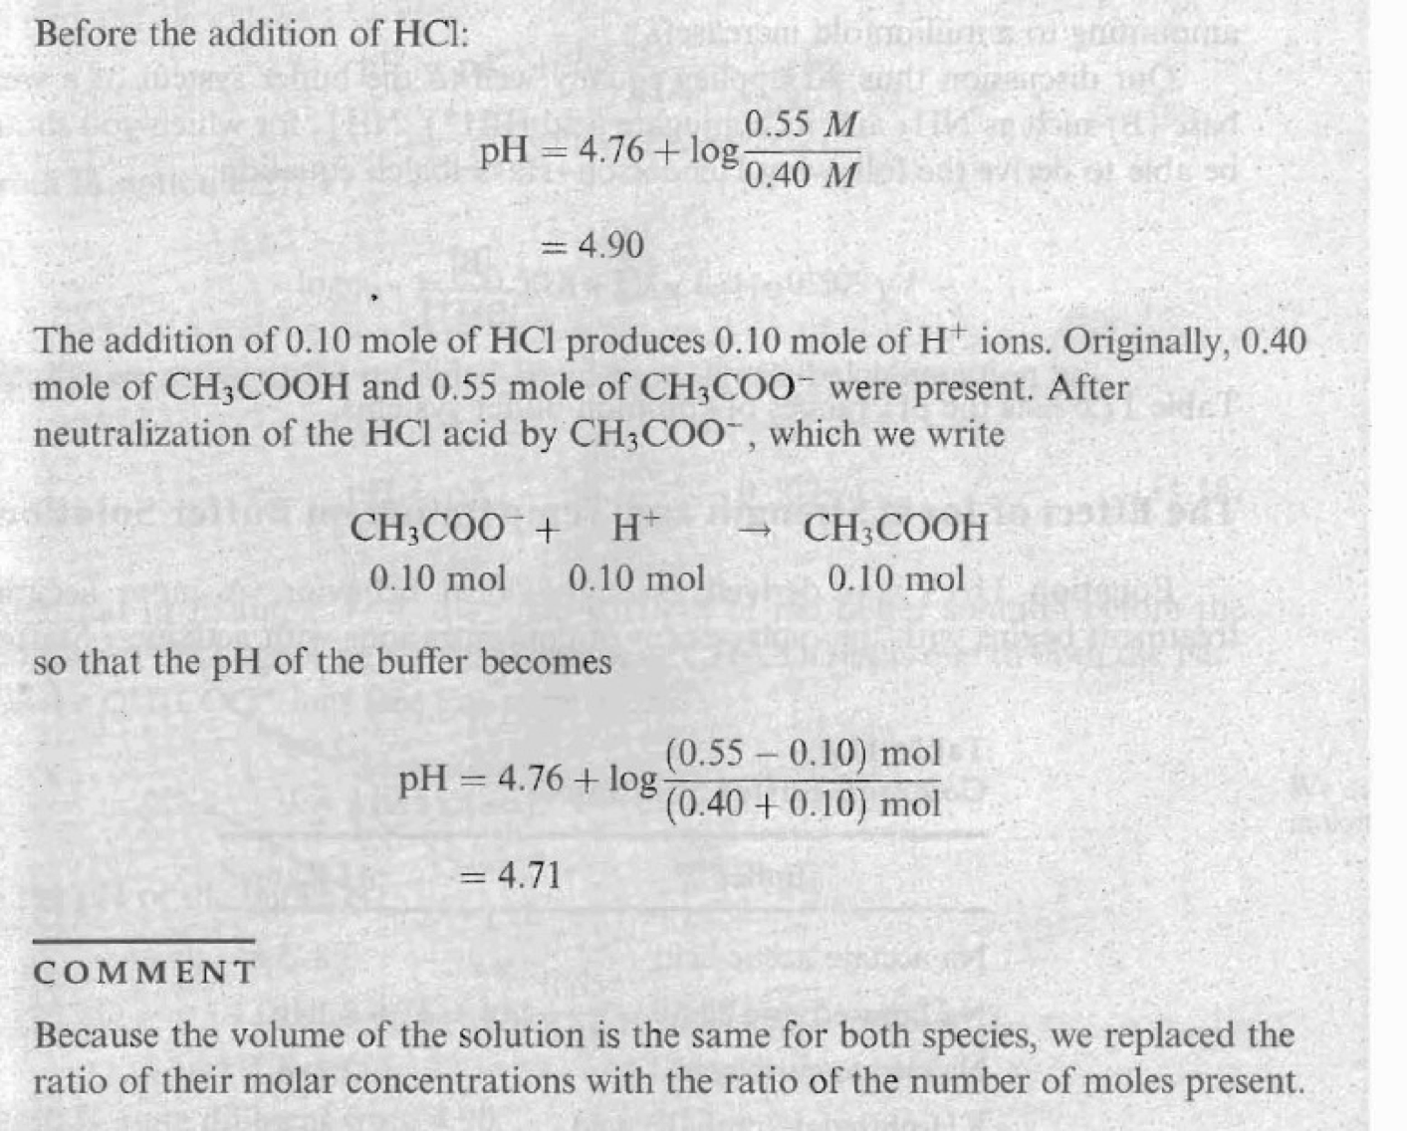

8.

