Solutions to Unit 4 Homework – Chemistry 1A

1. When brick 1 is brought in contact with brick 2, heat flows from brick 1 to brick 2, until thermal equilibrium is reached. This equilibrium occurs when the final temperature of the two bricks become 50oC. The heat flowing out of brick 1 equals the heat absorbed by brick 2.

Heat delivered by brick 1 is



This is the heat absorbed by brick 2. Therefore, for brick 2,



1.  Using the Van’t Hoff equation, a plot of lnK versus 1/T will yield the slope -ΔrHo/R.



In this case slope = 1505.9, or ΔH = -12.52 KJmol-1.

3. (a)

(b)

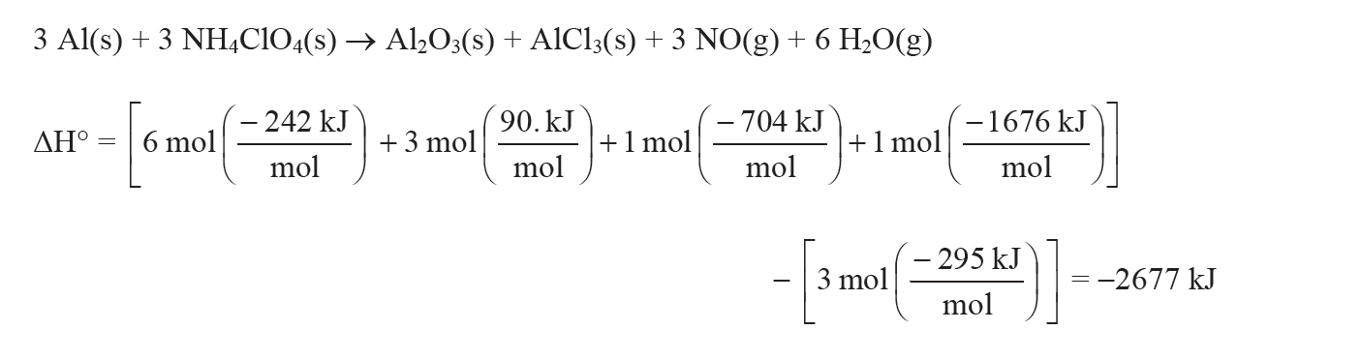

4/5/6 Are more or less the same kinds of problems.

7. We have the following information:

H2O (l)

H2O (l)

H2O (g)

H2O (g)

Ho(373K)

Ho(298K)

H1

H2

ΔvapHo at 373 K is 40.7 kJmol-1

(*l*) = 75.2 Jmol-1K-1

(*g*) = 33.6 Jmol-1K-1



8. 

9. (a) Using Hess’s law:



It follows that the standard enthalpy for the conversion of glucose to lactic acid during glycolysis is -120 kJ mol-1, about 4 % of the enthalpy change of combustion of glucose. Therefore, full oxidation of glucose is metabolically more useful than glycolysis, because in the former process more energy becomes available for performing work.

(b) Using Hess’s law:

C6H12O6(s)

*ΔHro*

2 C2H5OH(l) + 2 CO2 (g)

6 CO2(g) + 6 H2O(l)

- 2808 kJ mol-1

[+ 6O2(g)]

2( -1368 kJ mol-1)

= - 2736 kJ mol-1



1. The Kekulē structure of benzene has 3 C=C bonds and 3 C-C bonds. The total bond energy corresponding to the ring structure is 3(348) + 3(612) = 2880 kJ mol-1. Compare this to the resonance structure which has 6 aromatic C-C bonds, giving 6(518) = 3108 kJ mol-1. Thus, more energy is required to break the resonance form of benzene. The resonance form is therefore more stable than the corresponding Kekulē structure, by an amount 228 kJ mol-1.

11.



12







13

(a) The Mg2+ + ATP complexation can be studied in an electrochemical cell. We want to determine the activity (concentration) of Mg2+ at any concentration in the presence of 0.100 M ATP.

Putting ATP in a solution of known Mg2+(aq) will result in the consumption of some of the Mg2+, thus decreasing it to some lower value. We need to determine this new value.

Construct the following concentration cell.

(see next page).



Mg2+/ATP

**ANODE** **CATHODE**

Mg (s) → Mg2+ (*x* M) + 2e Mg2+ (1 M) + 2e- → Mg (s)

Mixture of Mg2+ and ATP Mg2+/Mg Standard conditions

The overall reaction is: Mg 2+ (1M) → Mg2+ (*x* M) with Eocell = 0V, and *n*  = 2.

The reaction quotient is 

The electrodes are identical, Eo are numerically equal. Therefore, Eocell = 0V.

However, the Mg2+ ion concentrations differ in each half-cell. This results in a potential difference that can be measured using the voltmeter. If the two half-cells were at equilibrium, then the Mg2+ concentrations would be identical, and Ecell = 0. However, this is not the case.

This is a concentration cell, and the value of Ecell can be used to determine the unknown concentration of Mg2+ in the LHS cell.

The Nernst equation for the above electrochemical cell is:



By measuring the potential difference, we can determine the activity of Mg2+ at any concentration in the presence of ATP.

(b) If ATP reacts with Mg2+, the new equilibrium concentrations will be:

[Mg2+]eq = *x* – *y*

[ATP]eq = 0.100 – *y*

[complex]eq = *y*

The equilibrium constant is given by 

Here, *x* refers to the initial concentration of Mg2+ which we know. The value *x* – *y* is simply the concentration of Mg2+ at equilibrium, which we have established in (a) (the activity).

Therefore we can determine *y* and hence the value of K.

**Note, although our reaction between Mg2+ and ATP reaches equilibrium in the LHS cell, the two half cells are not at equilibrium with respect to each other because the Mg2+ concentrations differ. If they were, we would not measure a potential difference between them, implying that the concentration of Mg2+ in the LSH cell must me 1M.**