Unit 1, Homework No. 3: Gibbs Energy and Thermochemical calculations

Solutions

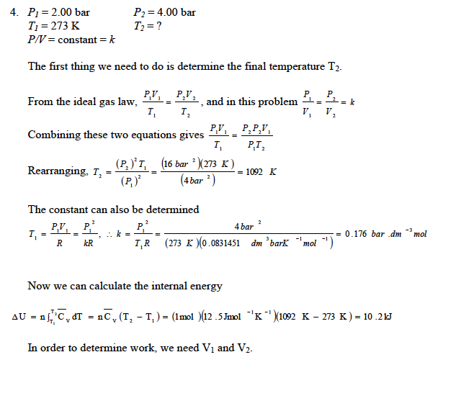
1.

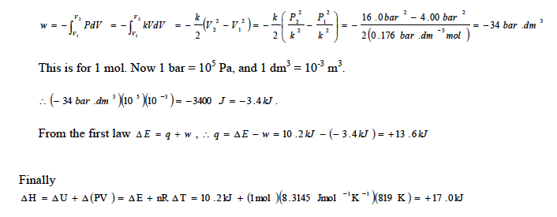
- Using the Van’t Hoff equation, a plot of lnK versus 1/T will yield the slope -Δ_{r}Hº/R.

$$\text{ln}\frac{K_{P}\left(T_{2}\right)}{K_{P}\left(T_{1}\right)}=−\frac{Δ_{r}H^{o}}{R}\left(\frac{1}{T_{2}}−\frac{1}{T_{1}}\right)$$

In this case slope = 1505.9, or ΔH = -12.52 KJmol⁻¹.

3. (a)

(b)

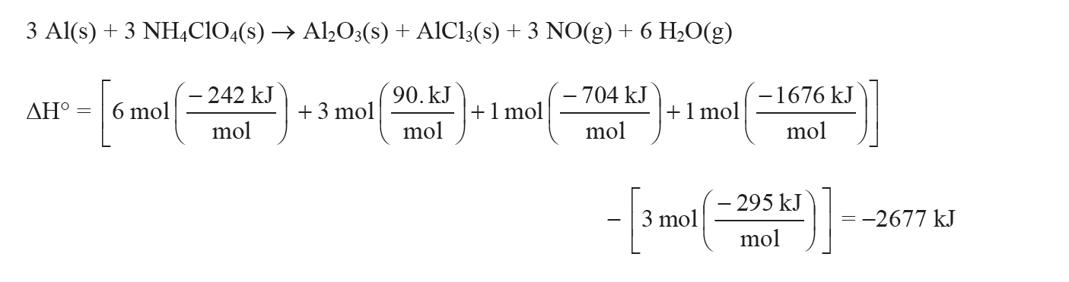

Last 2 should be easy enough!

