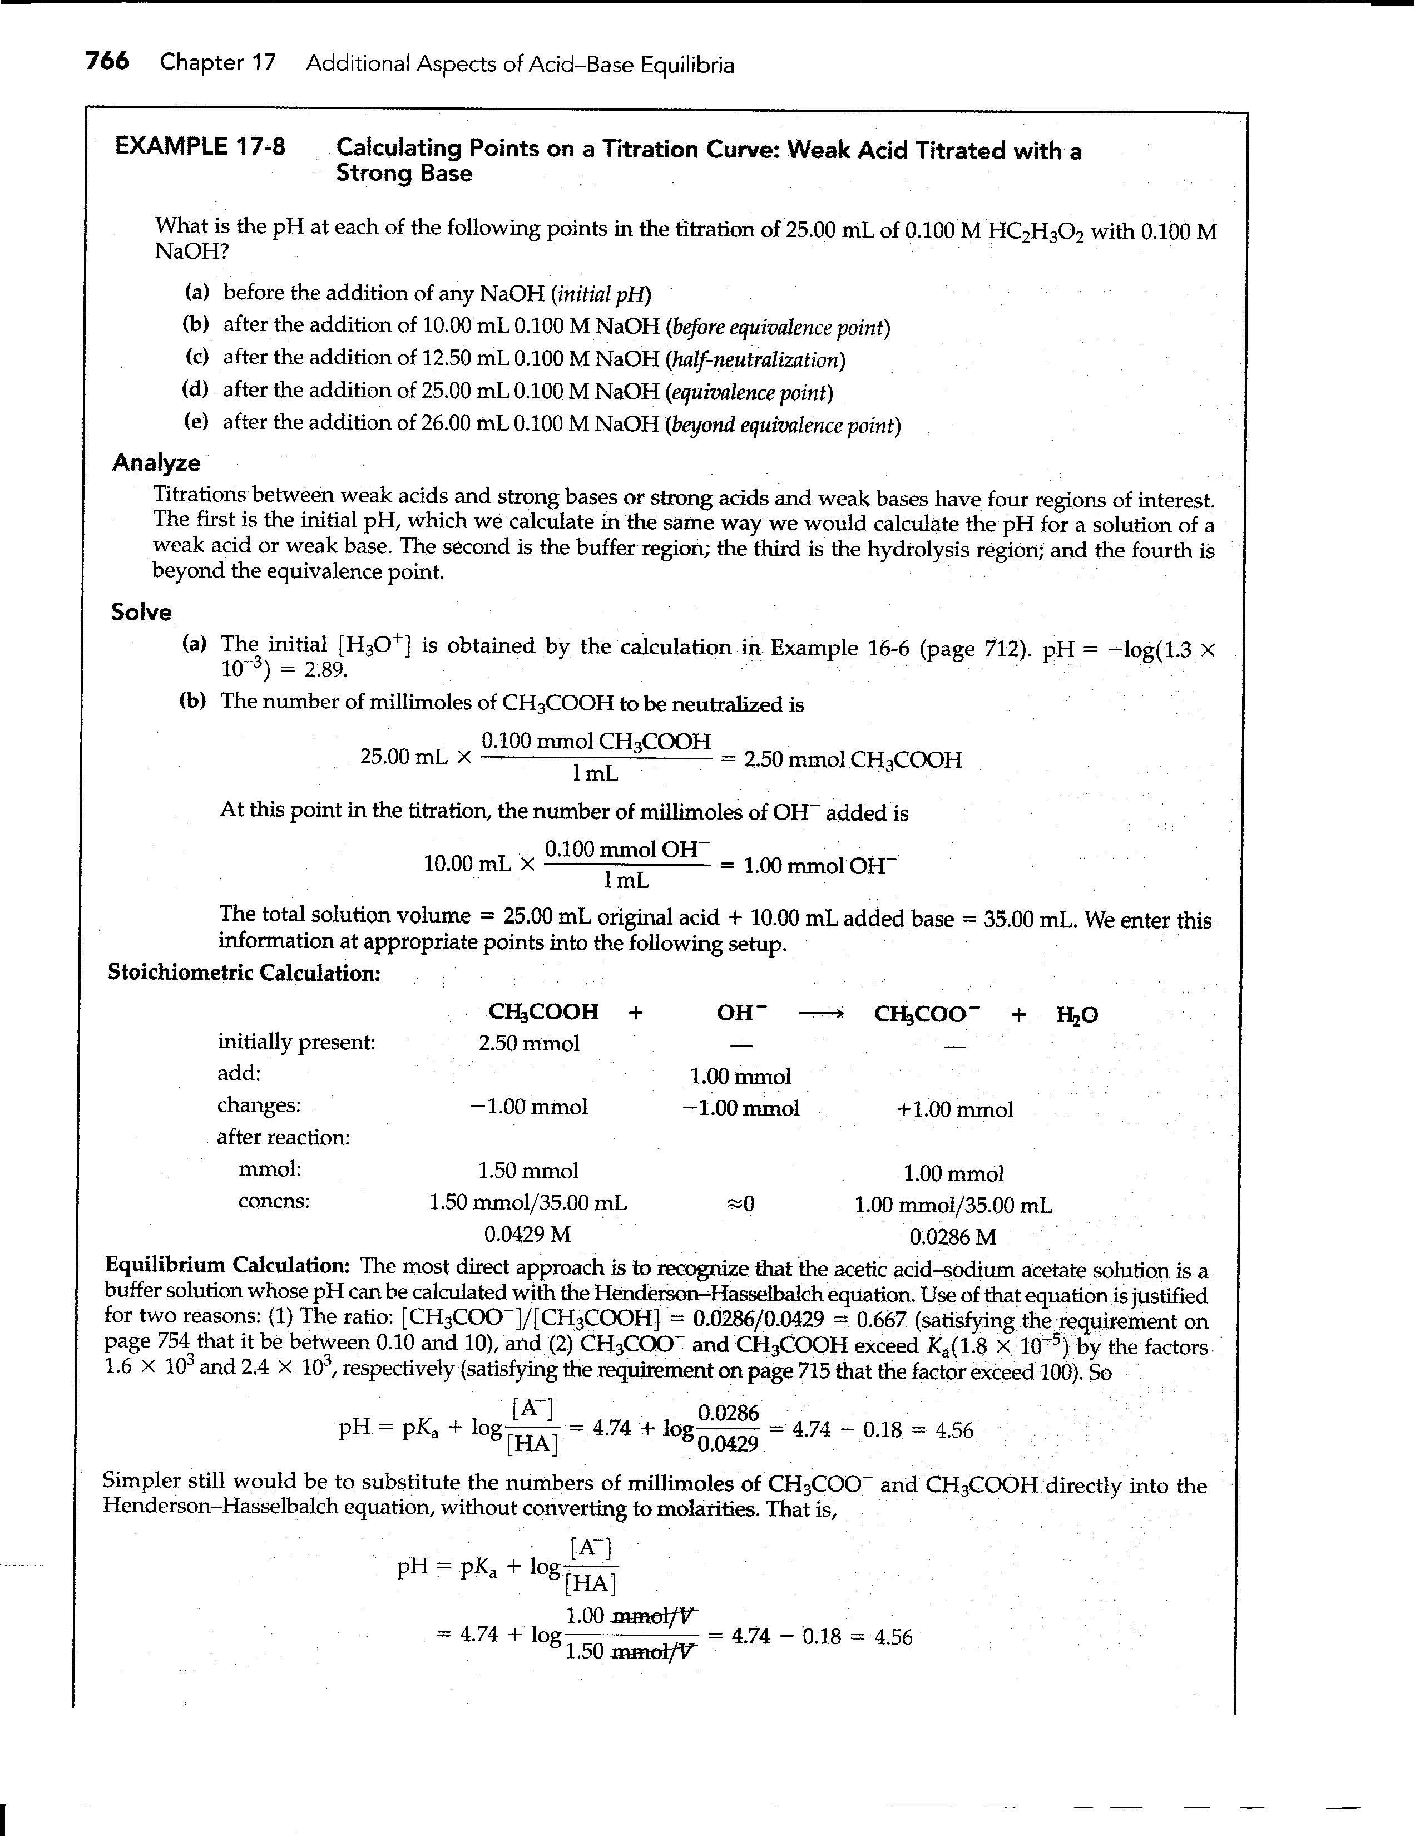
Unit 2, Homework No. 2: Acid-Base Equilibria and Solubility - SOLUTIONS
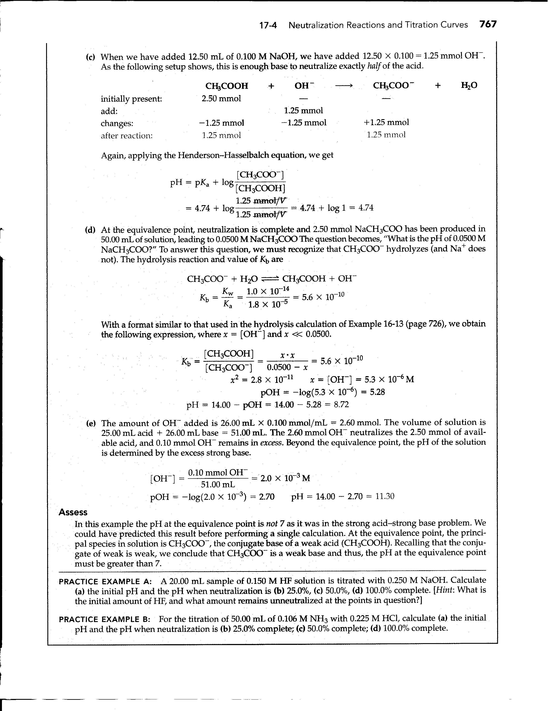
2. The ionic strength of a 1:1 electrolyte is equal to its concentration, c.
For a 2:1 electrolyte $I=\frac{1}{2}\sum_{j=1}^{s}{Z_{j}^{2}c_{j}}=\frac{1}{2}\left[\left(4×c\right)+\left(2×c\right)\right]=3c$.
$∴$ K₂SO₄ (aq) would have an ionic strength of 0.335 mol L⁻¹ when its morality is 0.112 mol L⁻¹.

3. Activity of Na₃Fe(CN)₆(aq) → 3 Na⁺(aq) + Fe(CN)₆³⁻(aq)

$$a_{2}={\left(c_{+}\right)}^{3}\left(c_{−}\right)γ_{±}^{4}={\left(3c\right)}^{3}\left(c\right)γ_{±}^{4}=\text{27}c^{4}γ_{±}^{4}$$

You need mean ionic activity coefficient. First determine ionic strength:
$$I=\frac{1}{2}\left[{\left(1\right)}^{2}\left(3c\right)+{\left(−3\right)}^{2}c\right]=6c=0\text{.}6×{\text{10}}^{−3}{\text{molL}}^{−1}$$
$\text{ln}γ_{±}=\frac{−1\text{.}\text{173}\left(3\right){\left(0\text{.}6×{\text{10}}^{−3}\right)}^{12}}{1+{\left(0\text{.}6×{\text{10}}^{−3}\right)}^{12}}=−0\text{.}\text{084}$, and $γ_{±}^{4}=0\text{.}\text{715}$
Finally, putting this into the equation for activity gives a₂ = 1.9 × 10⁻¹⁵ molL⁻¹

4.

D-H equation

